Managing Complications Manual

**Licensed for use by Divine You Ltd Training Academy**

All Rights Reserved

No part of this publication, document or any part thereof may be reproduced or transmitted in any form or by any means, electronic or mechanical, including photocopying, recording, storage in a retrieval system, or otherwise without the prior permission of the author.

**Course Details   
  
Aims**

The course aims to ensure you; the student understands the basics of health and safety and anatomy and physiology of the treatment. This manual covers the treatment background, benefits, consultation and contra-indications, contra-actions, aftercare and equipment and products required to perform the treatment. The practical techniques will be covered on the practical session to ensure competency in the procedure.

**Objectives**

At the end of the course, you will be able to perform a treatment in a professional, safe and hygienic manner in a commercially acceptable time, along with experience in carrying out a thorough consultation with the knowledge of the background, benefits, consultation, contra-indications, contra-actions, aftercare, equipment and the products needed.

**Accreditation**

This course is accredited by:

• Centre of CPD excellence

**Insurance**

Students will be able to gain insurance from the following provider(s) listed below, upon successful completion of your training:

Insurer name: insure smart ltd (Beazley)

Contact Number: 01592649786

Email Address: info@insure-smart.co.uk

Website: insure-smart.co.uk

Insurer name: insync insurance

Contact Number: 01200309516

Email Address: hello@insyncinsurance.co.uk

Website: insyncinsurance.co.uk

Insurer name: Westminster insurance

Contact Number: 01305839939

Email address: mail@westminster.global

Website: uk.westminster.global

**Medical Disclaimer**

It is advised that you take medical advice if you or any of your clients have a health problem. Any qualification from Divine You Ltd will not qualify you to advise on or diagnose any medical condition.

**Contact Details**

Trainer: Divine You Ltd

Address: Grange House, Lancaster Road, Shrewsbury SY1 3JF

Phone Number: 07581361136

Email Address: lynseydavies1@hotmail.com

Website: www.divineyou.co.uk

Facebook Page: www.facebook.com/divineyouXx

Instagram Account: www.instagram.com/divineyoushropshire

**Managing complications**

Therapists face the risk of incidents or complications within a clinic. Many therapists believe that the risk is only with injectable treatments; however, complications can occur for many treatments, even those that seem low risk.

High-risk treatments include but are not limited to:

* Mesotherapy
* Dermal filler or anti-wrinkle injections
* Vitamin injections
* Micro-needling
* Permanent makeup
* Microblading
* Chemical peels
* Electrolysis
* Platelet Rich Plasma Treatments
* Phlebotomy
* Cryotherapy
* Microdermabrasion
* Micro-sclerotherapy
* Laser and/or IPL
* Lash and brow tinting/hair dying

Some complications may be minor; however, despite the severity of injury to the client, we still have a responsibility to deal with the complaint and record the injury in our accident book. In some cases, these may need to be reported to RIDDOR.

Common injuries within a salon may include:

* Skin abrasions
* Burns
* Hyper-pigmentation.
* Swelling
* Bruising
* Allergic reactions

Any treatment can cause some kind of injury or complication. It is good practice to understand the risks of all procedures you perform, how to avoid them and how to prepare clients and inform them of the risks of the treatment they are undertaking.

If you are self-employed or run a clinic or salon with staff, you should be aware of all laws and bye-laws that are relevant to you.

Laws you should familiarise yourself with include:

* Health & Safety at Work Act
* Workplace (Health, Safety and Welfare) Regulations 1992
* Management of Health & Safety at Work Regulations 1999
* Data Protection Act and GDPR
* Control of Substances Hazardous to Health Regulations 2002 (COSHH)
* Manual Handling Operations Regulations 1992
* Personal Protective Equipment at Work Regulations 1992
* Provisions and Use of Work Equipment Regulations 1998
* Environmental Protection Act 1990
* EU Directive 2010/32/EU on the Prevention of Sharps Injuries in the Health Care Sector
* Waste Electrical and Electronic Equipment Regulations 2006 (WEEE)
* Regulatory Reform (Fire Safety) Order 2005
* Reporting of Injuries, Diseases and Dangerous Occurrences Regulations 1995
* Health and Safety (First Aid) Regulations 1981
* Electricity at Work Regulations 1989

By familiarising yourself with the law and local bye-laws, you will be better prepared to avoid accidents within the workplace as well as understanding risk and how to minimise it.

Understanding anatomy and physiology and the products you are using will also help reduce the risk of complications.

**Management of Sharps Injuries**

**What is a sharps injury?**

Exposure to blood or bodily fluids caused by either laceration or puncture of the skin. Sharps used in a salon or clinic setting include hypodermic needles, electrolysis needles, scalpels, derma-rollers, stamps, derma-pens or any item that can cut or pierce the skin.

What is a Splash incident?

A splash incident is where blood or bodily fluids come into contact with the eyes, mouth, broken skin or any mucous membranes.

**Who is at risk?**

Any therapist, client, staff member or visitor is at high risk of injury.

**What is the risk?**

The risk of blood to blood contact increases the risk of contracting blood-borne viruses such as HIV, Hepatitis B and Hepatitis C.

Accidental exposure to blood or other bodily fluids from clients can lead to an infection if the client is infected with any of the aforementioned blood-borne viruses.

The risk of transmission from an infected client can be as much as 1 in 3 with Hepatitis B, 1 in 30 with Hepatitis C and 1 in 300 for HIV.

**Minimising risk**

Risk can be reduced by following some simple steps and being cautious whilst performing treatments on a client. Anyone working with needles or at risk of coming into contact with blood should have a Hepatitis B vaccination. This can usually be provided by your GP or local travel centre. A course of injections is required for long-term immunity. There are currently no vaccines available for Hepatitis C or HIV.

**Measures to reduce the chance or exposure**

* Wash hands before and after contact with every client and before putting on and after removing gloves.
* Gloves should always be changed between clients.
* Cover any existing wounds, skin lesions and any breaks in the skin with a waterproof dressing and wear gloves in hands are extensively affected.
* Always wear gloves where contact with blood is a possibility.
* Wear closed footwear in situations where you are working with sharps. These should also be flat, comfortable and have non-slip soles.
* Clean up all areas and disinfect surfaces that have come into contact with blood or blood-contaminated dressings, needles or wipes between clients.
* Wear gloves when sterilising equipment or cleaning work surfaces, beds or spills or when handling chemicals.
* Follow safe procedures for disposal of contaminated waste.
* Only use new, single-use disposable equipment for all injections if available.
* Where reusable equipment or products come into contact with the skin or blood, you must follow a protocol to clean, disinfect and sterilise the equipment appropriately.
* Dispose of contaminated sharps immediately in a sharps bin after use and never re-sheath the needles.
* Sharps boxes should be replaced when they are ¾ full.
* Sharps should not be passed directly from hand to hand, and handling should be kept to a minimum.
* Used needles must not be bent or broken before disposal.
* Sharps containers should be located in a safe place and in a position that avoids spillages and is away from public access or the reach of children.
* Sharps containers should only be used for the disposal of sharps.
* Temporary close the sharps box when not in use.
* Sharps bins should be disposed of every three months, whether they are full or not, by a licensed route in accordance with local policy.
* Use correct PPE such as gloves, aprons, facemasks and goggles.

**Treatment rooms**

Treatment rooms should be set up so that the therapist does not have to leave the client unattended, and you should have everything you need to hand.

Rooms should ideally have:

* A sink with hot and cold running water and an elbow lever tap.
* Hand soap and hand sanitiser that is wall mounted.
* A good supply of gloves, masks, aprons and hand towels.
* A Sharps box should be in easy reach of the treatment area on a secure surface and out of reach of the client.
* Good lighting to ensure you can clearly see what you are doing.
* Floors that are non-slip and easy to clean.
* Wipeable surfaces with no soft furnishings or towels that may be contaminated during a procedure.
* Hand washing signs should be displayed to remind yourself and staff of the correct practice for hand washing.
* Other signs including first aid charts, anaphylaxis checklist and sharps injury checklist.
* A lockable fridge or cupboard where prescribed medicines or high-risk products should be stored.
* A first aid kit and your complications kit.



**Consultation Process and Recording Treatment Outcomes**

The consultation process is the most important part of the treatment. This is where you get to establish the needs of the clients, their expectations and their medical history that may mean the treatment has to be adapted or avoided.

This is the time to explain to the client the risks of any procedure and what side effects can occur post-treatment and aftercare.

Many complaints or issues can be resolved by proper consultation at the start of treatment. It is also a good record in case of the event of a claim.

The consultation process should include:

* Confirming the client’s name and contact details. I believe that ID should also be seen at this time to protect you as a therapist from theft, false claims or treating underage clients.
* A detailed record of the client’s medical history to establish that it is safe to perform the treatment.
* Record previous treatments the clients had and when.
* Explain the treatment to the client in detail alongside all side effects, potential risks and complications and get them to sign their consultation form to agree that this has been discussed.
* Aftercare and review dates should be discussed and a copy of this handed to your client.
* Establish the outcome the client is after and work towards managing their expectations.

All consultation forms should be locked away and secure, with only relevant people having access to these records.

Clinics require registration with the ICO to ensure they abide by local GDPR law.

Any documents or images should be stored on an encrypted hard-drive.

Clients permission should be sought if you wish to use any before or after images on social media, websites or other advertisements.

When you undertake the treatment, it is also vital you keep a detailed record. Clients should re-sign their consultation forms at every visit to ensure no changes have happened since their last visit.

Details on the treatment performed should be recorded on the consultation form, and these include:

* Treatment or treatments performed and where.
* Products used along with batch numbers or proof of prescriptions for that client. Medicines or serums have stickers on the product or inside the box to attach to the form.
* Make a note of how much product you used, injection sites and needle types.
* Keep records of the needle and syringe batch numbers or staple the empty packets onto your form.
* Record any contra-actions such as swelling, redness, bruising or abrasions etc.
* Record clients reactions during the procedure.
* Make a note of how the client reacted post-procedure and possibly get them to write any feedback of their experience on the form. (this is not the same feedback as clients would leave online). This may include:
  + How the client felt during the procedure (discomfort/sore/scared)
  + What the client expected vs what they received
  + How they feel after the procedure

The more information documented, the easier it is to manage future appointments for your clients as well as quickly deal with any complications, complaints or claims.

**Managing Client Expectations**

Due to the recent boom of social media and, in more recent years, the rise of filter use, we have entered an age where clients strive for perfection. Rates of cosmetic interventions continue to increase, with non-surgical procedures being five times more popular than surgical treatments. Along with this is an increase in the client’s expectations that a procedure may be instant and risk-free, thus setting their expectations before they visit the clinic. In order to satisfy the client would be to meet these sometimes unrealistic and unattainable expectations.

This is why it is extremely important to undertake a full client consultation prior to treatment to identify the client’s expectations and see if these are reasonable or achievable.

When expectations are not met, the client will usually make a complaint via a number of channels, one of which has become more common is through social media. A client may raise their concerns or dissatisfaction directly first, and it is down to you to control the complaint and try to meet those expectations that could have been managed at the consultation. If you are unable to appease the client, then they may set about leaving negative reviews online or through various social media channels damaging your reputation. This could also become more formal and result in a claim for damages.

It is vital that you undertake a full consultation at every procedure and establish the client’s expectations and manage them prior to the treatment. This allows the client to make a more informed decision on whether or not to have the procedure or whether you should refuse the treatment because you know that the expectations are unrealistic.

**Establishing the client’s expectations**

It is important for the therapist to seek out what motivated the client to book in for a particular procedure. This can be in itself somewhat complex.

Age is often a factor; younger clients are more sensitive to the opinions of their peers and to images on social media as well as celebrities they may look up too. Some may want to correct a feature that may not feel attractive to them, or they may wish to enhance their appearance for social media or to look like or behave like a particular celebrity.

Media plays a large part in the rise of unrealistic expectations. Television. Films, magazines all show images of idealised appearances. Social media and creating the perfect selfies has led to the rise in body image dissatisfaction and appearance. It has also been the mitigating factor for an increase in cosmetic procedures.

Family members and partners, as well as friends, are extremely influential over an individual’s choices. It may be that the client wants the procedure as all their friends are doing the same, or they could have been pushed into the treatment by someone else. It’s good practice to not only enquire if they know of anyone else that has the procedure done already but to ensure that family, friends and their partner are aware they are having the treatment. Finding out the families or partners views can also later alleviate any concerns the client may have. Having a family member or partner point out their concerns over how the client may look post-treatment can lead to the client regretting the procedure or wanting reassurance that side effects are normal and will subside.

If the client has low self-esteem, this may lead to unobtainable and unrealistic goals and expectations. High neuroticism and anxiety may influence their expectations, and the outcome tends to be poorer. Body dysmorphic disorder can be a contra-indication to treatment, and it is often very difficult to satisfy or meet the client’s expectations.

Once you have educated the client on the treatment and all the potential risks, side effects and complications, they may modify their expectations and better knowledge is associated with better outcomes. Sometimes the client may choose an alternative procedure than the one they booked in for that may have lower risks or may meet their expectations better.

The cost of the procedure should also be discussed with the client. This may be that several treatments will be required to meet their expectations, or they may not be aware of ongoing maintenance costs or treatment longevity.

All therapists have a duty to work within the limits of their competence and experience and should have appropriate expectations as to what can be achieved for every client. There may be alternative and more suitable treatment options available, especially if several aspects of the client’s appearance is being treated. It is the therapist’s duty to know what is realistic and feasible and prioritise accordingly. In this context, expectations of timescale may also be important, especially if desired results are required prior to a specific event or date.

It may be necessary to turn down a client’s request for a particular treatment. It is important that you explain your reasons why to the client to try and avoid them seeking treatment at another clinic where less scrupulous therapists. This discussion should also explain what other treatment options are available and may be more appropriate for the client.

The therapist should have a thorough knowledge base on every product they use in order to know what outcome to expect. This knowledge should not only derive from that from the manufacturer but from regular education and peer to peer discussion.

Clients should be fully informed of the risks and side effects of their chosen treatment plan to reduce dissatisfaction. Ongoing advice and support are also important in modifying a client’s unfulfilled expectations. Ideally, all clients should have a follow-up appointment to determine whether expectations have been met or not.

Obtaining informed consent is an essential pre-requisite for any treatment. Informed consent cannot be acquired without an exploration of the factors mentioned above. An understanding of what the client wants and expects, along with an educated understanding of the client’s condition and an explanation of what the therapist hopes to achieve, are all central to the principles of informed consent. The process of eliciting consent should be recorded, as should the explanation of possible adverse effects. Providing written information to the client may augment the process of consent to treatments.

Recent GMC guidelines on cosmetic treatments stress the importance of giving clients time to reflect on all the information that they have been given. The duration of this ‘cooling off’ period has no time specification.

**First Aid & Emergency Kit**

The HSE recommends that businesses with fewer than 50 staff members should have at least one qualified and appointed First Aider.

First Aid courses can last anything from half a day to 3 days. The half-day courses are not usually accredited, so it is highly recommended to at least complete a full day of First Aid training.

These regulations also require that every employer provides equipment or facilities for providing First Aid to their employees. Even if you do not have employees, having a First Aid Kit to hand when required is good practice.

It is essential you know how to respond in an emergency. We will cover a few more common first aid emergencies below; however, this does not replace proper first aid training.

**Before delivering any first aid, you must first follow the DRSABCD protocol.**

The DRSABCD is an Acronym that is also referred to as the Primary Survey. It is one of the first things that should be done when encountering a casualty with injuries or an illness.

**Danger**

The first step is to visibly check for dangers to the casualty and to yourself. The first aider should never put themselves in danger. Common examples of dangers include electricity and the oncoming risk of traffic.

**Response**

An international way of getting a response from a casualty is to gently shake them on the shoulders. Speak clearly into both ears as the casualty may have had their hearing affected through the accident or could even be deaf. It is important to speak in a positive and friendly manner.

**Shout**

When no help is around, shout loudly to alert others of the situation. Do not leave the casualty at this point, as it is very important to complete the final stages of the acronym.

**Airways**

The airway will need to be clear in order for the casualty to breathe sufficiently. Visibly check the mouth for any obstructions, vomit or blood.

Open the airway for the casualty to prevent the tongue from blocking the airway. This is achieved by tilting the head backwards and lifting the chin upwards.

**Breathing**

The casualty’s breathing will need to be checked when they show no signs of responding. Keep this simple and address the three main signs:

1. **Look** - to see if the casualty’s chest is rising and falling.
2. **Feel**- Position your cheek about an inch away from the casualty’s face. Can you feel breaths?
3. **Listen** - The subtle sounds of the breathing process may be apparent.

The three signals may not always be apparent. Sometimes the [first aider](https://www.train-aid.co.uk/courses/emergency-first-aid-at-work) will rely on two strong signals on in harder cases, just one.

The secondary assessment can start once it has been established that the casualty is breathing. When not breathing, keep moving through the acronym.

**Circulation**

Cardiopulmonary Resuscitation (CPR) should be started when it has been established that the casualty is not breathing. The Emergency Services will need to be informed immediately with the information that someone has stopped breathing.

**Defibrillation**

[Automated External Defibrillators](https://www.train-aid.co.uk/courses/aed-defibrillator-training) (AED) are present in certain environments, such as public places and town centres. These could prove a lifesaver if someone has suddenly stopped breathing and should be fetched by another first aider or bystander whilst CPR continues.

Remember, the ambulance / first responder will always have an AED, so make the call as soon as you know someone has stopped breathing.

**Asthma Emergency**

An asthma emergency is potentially life-threatening.

Most people who suffer from asthma attacks are aware of their asthma and should have an action plan and medication. They may wear a medical alert device. In an emergency, or if a patient does not have their own reliever, use another person’s reliever (where permitted under local state or territory regulations) or one from a first aid kit. If the patient is having difficulty breathing but has not previously had an asthma attack, follow WHAT TO DO.

**SIGNS AND SYMPTOMS MILD TO MODERATE ASTHMA ATTACK**

* Increasingly soft to loud wheeze
* Persistent cough
* Minor to obvious difficulty breathing

**ASTHMA EMERGENCY**

* Symptoms get worse very quickly
* Little or no relief from an inhaler
* Severe shortness of breath-focused only on breathing
* Unable to speak normally
* Pallor, sweating
* Progressively more anxious, subdued or panicky
* Blue lips, face, earlobes, fingernails
* Loss of consciousness

**WHAT TO DO**

1. Follow the DRSABCD protocol
2. Help the client to sit down in a comfortable position.
3. Reassure and stay with the client.
4. If requested, help the client to follow their action plan.

**HOW TO GIVE MEDICATION (4: 4: 4)**

Use a spacer if available.

1. Give four separate puffs of blue/grey reliever puffer:
   1. shake the inhaler
   2. give one puff
   3. take four breaths
   4. repeat until four puffs have been given.
2. Wait 4 minutes.
3. If there is no improvement, give four more separate puffs of blue/grey reliever as above.
4. If the patient still cannot breathe normally, call 999 for an ambulance.
5. Keep giving four puffs every 4 minutes (as above) until medical aid arrives.

**Severe Bleeding**

**WARNING**

* Any severe bleeding should be stopped as soon as possible
* DO NOT give the patient anything to eat or drink
* Wear gloves, if possible, to prevent infection.
* If an object is embedded in or protruding from a wound, apply pressure on either side of the wound and place pads around the object before bandaging.

**SIGNS AND SYMPTOMS**

As well as the obvious sign of blood coming from a wound, signs and symptoms of severe bleeding include:

* Weak, rapid pulse
* Pale, cool, moist skin
* Pallor, sweating
* Rapid, gasping breathing
* Restlessness
* Nausea
* Thirst
* Faintness, dizziness or confusion
* Loss of consciousness.

**WHAT TO DO**

1. Follow DRSABCD.
2. Help the client to lie down, particularly if the bleeding is severe.
3. Remove or cut the client’s clothing to expose the wound if needed.
4. Ask the client to apply direct pressure over the wound or as close to the point of the bleeding as possible. If the client is unable to apply pressure, use a pad or your hands.
5. Squeeze the wound edges together if possible.
6. Apply a pad over the wound if not already in place.
7. Secure the pad by bandaging over it. Ensure the pad remains over the wound.
8. If bleeding is still not controlled, leave the initial pad in place and apply a second pad and secure it with a bandage.
9. If bleeding continues through the second pad, replace the second pad leaving the first pad in place, and rebandage.
10. Do not give the severely bleeding client any food or drink, and call 999 for an ambulance.
11. Check every 15 minutes that the bandages are not too tight and that there is circulation below the wound.
12. Continue to check the client’s breathing.

**Burn or Scald**

**WARNING**

* Do not apply lotions, ointments, fat or ice to a burn.
* Do not touch the injured areas or burst any blisters.
* Do not remove anything sticking to the burn.
* If the burn is larger than a 20p piece, or deep, seek medical aid.

**SIGNS AND SYMPTOMS**

**Superficial burns**

The area is:

* Red
* Very painful
* Blistered.

**Deep burns**

The area is:

* Mottled red and white
* Dark red or pale yellow
* Painful
* Blistered.

**Full-thickness burns**

The area:

* Is white or charred
* Feels dry and leathery.
* Because the nerves are destroyed, the pain will not be as great as in a superficial burn.

**WHAT TO DO**

**If the patient’s clothing is on fire**

1. Stop the patient from moving around.
2. Drop the patient to the ground and cover or wrap them in a blanket or similar, if available.
3. Roll the patient along the ground until the flames are extinguished.
4. Manage the burn.

**For all other burns**

1. Follow DRSABCD.
2. If the burn is severe or if it involves the airway, call 999 for an ambulance.
3. As soon as possible, hold the burnt area under cool running water for 20 minutes.
4. Remove any clothing and jewellery from the burnt area unless they are stuck to the burn.
5. Cover the burn with a light, loose non-stick dressing, preferably clean, dry, non-fluffy material (e.g. plastic cling film).
6. Continue to check the patient for shock and treat if necessary.

**Concussion**

**SIGNS AND SYMPTOMS**

Some or all of the following may indicate concussion:

* Loss of consciousness
* Persistent headache
* Faintness, dizziness
* Confusion
* Loss of memory, particularly of the event
* Blurred vision
* Slurred speech
* Altered or abnormal responses to commands and touch
* Vomiting within a few hours after a head injury
* Wounds to the scalp or face.

**WARNING**

Any person who has suffered a loss of consciousness or an altered state of consciousness after a blow to the head should not return to their activity (e.g. sport) and should see a medical practitioner urgently.

**WHAT TO DO**

1. Follow DRSABCD.
2. If the client is conscious and no spinal injury is suspected, place the client in a position of comfort (usually lying down) with their head and shoulders slightly raised.
3. Advise them to seek medical attention.
4. If the client is unconscious and a neck or spinal injury is suspected, place the client in the recovery position, carefully supporting the patient’s head and neck, and avoid twisting or bending during movement.
5. Call 999 for an ambulance.
6. Ensure the client’s airway is clear and open. Keep the client’s airway open by lifting their chin. DO NOT force if the face is badly injured.

**HEAD INJURY**

1. Control any bleeding with direct pressure at the point of bleeding. If you suspect the skull is fractured, use gentle pressure around the wound.
2. If blood or fluid comes from the ear, secure a sterile dressing lightly over the ear. Lie the patient on their injured side, if possible, to allow the fluid to drain.
3. Ensure an ambulance has been called, noting the patient’s condition so that you can report it to the paramedics.

**Choking**

**WARNING**

If the client becomes blue, limp or unconscious, follow DRSABCD and call 999 for an ambulance.

**SIGNS AND SYMPTOMS**

* Clutching the throat
* Coughing, wheezing, gagging
* Difficulty in breathing, speaking or swallowing
* Making a whistling or ‘crowing’ noise, or no sound at all
* Blue lips, face, earlobes, fingernails
* Loss of consciousness

**WHAT TO DO**

1. Encourage the client to relax. Ask the client to cough to remove the object.
2. If coughing does not remove the blockage, call 999 for an ambulance.
3. Bend the client well forward and give up to 5 sharp blows on the back between the shoulder blades with the heel of one hand. Check if the blockage has been removed after each blow.
4. If the blockage has not cleared after five back blows, give up to 5 chest thrusts. Give chest thrusts by placing one hand in the middle of the client’s back for support and the heel of the other on the lower half of the sternum. Thrusts should be slower and sharper than CPR compressions. Check if the blockage has been removed after each thrust.
5. If the blockage has not cleared after five thrusts, continue alternating five back blows with five chest thrusts until medical aid arrives.
6. If the client becomes blue, limp or unconscious, follow DRSABCD and call 999 for an ambulance.

**Diabetes Emergency**

**SIGNS AND SYMPTOMS**

**High blood sugar**

* Excessive thirst
* Tiredness
* Blurred vision
* Hot, dry skin
* The smell of acetone on the breath

**Low blood sugar**

* Weakness, shaking
* Sweating
* Headache
* Faintness, dizziness
* Lack of concentration
* Teariness or crying
* Irritability or altered behaviour
* Hunger
* Numbness around the lips and fingers

**These may progress quickly to:**

* Slurred speech
* Confusion
* Loss of consciousness
* Seizures.

**WHAT TO DO**

**High blood sugar (hyperglycaemia)**

1. If the client has medication, ask if they need assistance administering it. Only help the client if they request it.
2. Encourage the client to drink water.
3. Seek medical aid if symptoms worsen.
4. If the client has not yet been diagnosed with diabetes, encourage them to seek medical aid.

**Low blood sugar (hypoglycaemia)**

1. Help the client to sit or lie in a comfortable position.
2. Reassure the client.
3. Loosen any tight clothing.
4. Give the client sugar, such as fruit juice or a soft drink (NOT ‘diet’ e.g. Coke Zero, Pepsi Max), sugar, jellybeans, glucose tablets.
5. Continue giving sugar every 15 minutes until the client recovers.
6. Follow with carbohydrates, e.g. a sandwich, milk, fresh or dry fruit, or dry biscuits and cheese.
7. If there is no improvement in symptoms or the client becomes unconscious, call 999 for an ambulance.

**Electric Shock**

**WARNING**

Even for a mild electric shock, encourage the patient to seek medical aid for assessment of potential effects on the heart.

**SIGNS AND SYMPTOMS**

* Difficulty in breathing or no breathing at all
* A weak, erratic pulse or no pulse at all
* Burns, particularly entry and exit burns
* Loss of consciousness
* Cardiac arrest

**WHAT TO DO**

1. Check for danger to yourself, bystanders and the client.
2. Switch off the power, if possible, before trying to help the client.
3. If the client is in contact with high voltage lines, do not approach but wait until power is disconnected by authorised electrical personnel.
4. If power cannot be switched off quickly, remove the client from the electrical supply without directly touching them. Use a non-conductive, dry material (e.g. a dry wooden broom handle).
5. Follow DRSABCD. Call 999 for an ambulance.
6. Hold any burnt area under cool running water for 20 minutes.
7. Remove jewellery and clothing from burnt areas unless stuck to the burn.
8. Cover the burnt area with a loose and light non-stick dressing, preferably clean, dry, non-fluffy material such as plastic cling film.
9. Seek medical aid.

**Epileptic Seizure**

**WARNING**

**During a seizure**

* DO NOT try to restrain the person or stop the jerking.
* DO NOT put anything in their mouth.
* DO NOT move the person unless they are in danger.

**SIGNS AND SYMPTOMS**

A client having an epileptic seizure may:

* Suddenly cry out
* Fall to the ground, sometimes resulting in injury
* Stiffen and lie rigid for a few seconds
* Have rhythmic jerking muscular movements
* Look very pale and have blue lips
* Have excessive saliva coming out of their mouth
* Sometimes biting the tongue or cheek, resulting in blood in the saliva
* Lose control of their bladder or bowel
* Be extremely tired, confused or agitated afterwards.
* Lose control of their bladder or bowel
* Be extremely tired, confused or agitated afterwards.

**What to do**

**During the seizure**

1. Protect the client from injury by removing any objects that could cause injury.
2. Protect the client’s head by placing something soft under their head and shoulders.
3. Time the seizure.

**After the seizure**

1. Put the client in the recovery position as soon as jerking stops, or immediately if they have vomited or have food or fluid in their mouth.
2. Manage any injuries resulting from the seizure.
3. DO NOT disturb the client if they fall asleep but continue to check their breathing.
4. Calmly talk to the client until they regain consciousness. Let them know where they are, that they are safe and that you will stay with them while they recover.
5. Call 999 for an ambulance if:
   * + The seizure continues for more than 5 minutes or a second seizure quickly follows.
     + The client remains unresponsive for more than 5 minutes after a seizure stops.
     + The client has been injured.
     + The client has diabetes or is pregnant.
     + you know, or believe it to be the client’s first seizure

**Eye Injuries**

**WARNING**

* Act with extreme urgency (within seconds) if it is a heat or chemical burn.
* Do not touch the eye or contact lens.
* Do not allow the patient to rub the eye
* Do not try to remove any object that is embedded in or penetrating from the eye.
* Do not persist in examining the eye if the injury is severe.
* Do not apply pressure when bandaging the eye.

**SIGNS AND SYMPTOMS**

* Pain
* Redness
* Wateriness
* Sensitivity to light
* Swollen or spasming eyelids
* Bleeding
* Inability to open the eye
* Injuries around the eye

**WHAT TO DO**

1. Follow DRSABCD.
2. DO NOT try to remove an object that is embedded in, or protruding from, the eye.
3. Cover the injured eye only with one or more sterile pads, avoiding any protruding object.
4. DO NOT put direct pressure on the eyeball.
5. Help the patient to lie down in a comfortable position on their back.
6. Ask the patient to try not to move their eyes.
7. Seek medical aid.

**Heart Attack**

**SIGNS & SYMPTOMS**

The warning signs of a heart attack vary. Symptoms can start suddenly or develop over time and get progressively worse. People can have just one symptom or a combination of symptoms. The client can feel discomfort or pain in the centre of the chest. This chest pain can:

* Start suddenly or slowly over minutes.
* Be described as tightness, heaviness, fullness or squeezing.
* Be severe, moderate or mild.

**Chest pain may spread from:**

* Discomfort in the neck or a choking or burning feeling in the throat
* An ache, heaviness or pressure around one or both shoulders
* Pain, discomfort, heaviness or uselessness in one or both arms
* An ache or tightness in/around the jaw
* A dull ache between the shoulder blades
* Pain, heaviness, tightness or crushing sensation in the centre of the chest.

**However, not all patients feel chest discomfort (more than 40% of women do not experience chest pain). The client can also feel:**

* Short of breath
* Nauseous
* Faint or dizzy
* A cold sweat.

**WARNINGS**

* Having one or more signs or symptoms of a heart attack means this is a life-threatening emergency—call 999 for an ambulance immediately.
* It is not recommended that you drive the client to the hospital yourself, as you may need to perform CPR.

**WHAT TO DO**

1. Follow DRSABCD.
2. Encourage the client to immediately stop what they are doing and rest.
3. Help the client to sit or lie down in a comfortable position.
4. Reassure the client. Loosen any tight clothing.
5. If the client has been prescribed medication such as a tablet or mouth spray to treat episodes of chest pain or discomfort associated with angina, help them to take this as they have been directed.
6. Ask the client to describe their symptoms. If any of the symptoms are severe, get worse quickly, or have lasted 10 minutes, call 999 for an ambulance and stay on the phone. Wait for advice from the operator.
7. Stay with the client until medical aid arrives.
8. Be prepared to give CPR if symptoms worsen.

**Shock**

**SIGNS AND SYMPTOMS**

**Initial shock**

* Pale face, fingernails and lips
* Cool, moist skin
* Faintness, dizziness
* Nausea
* Anxiety Severe shock
* Restlessness
* Thirst
* Weak, rapid pulse, which may become weaker or slower
* Shallow, fast breathing
* Drowsiness, confusion
* Blue lips, face, earlobes, fingernails (this is a late sign and means the patient is very sick)
* Unconsciousness

**WARNING**

Shock is a life-threatening condition.

Any health condition or trauma can cause shock.

It is important that you treat the injury or illness that is causing the shock, as well as treating the shock and the person as a whole.

**WHAT TO DO**

1. Follow DRSABCD.
2. Help the client to lie down. Do not raise their legs.
3. Reassure the client.
4. Manage severe bleeding, then treat other injuries.
5. Loosen any tight clothing.
6. Keep the client warm with a blanket or similar. Do not use any source of direct heat.
7. Give the client small amounts of cool water to drink frequently if they are conscious, do not have abdominal trauma, and are unlikely to require an operation immediately.
8. Place the client in the recovery position if they have difficulty breathing, become unconscious or are likely to vomit.
9. Seek medical aid or 999 for an ambulance if the client’s injuries require it.

**Stroke**

**RECOGNISE STROKE?**

**ACT FAST!**

**F**– Has the person’s FACE drooped?

**A** – Can they lift both ARMS?

**S** – Is the person’s SPEECH slurred? Do they understand you?

**T** – Call 999! TIME is critical

**SIGNS AND SYMPTOMS**

* Facial weakness
* Arm weakness
* Weakness or paralysis, especially on one side of the body
* Difficulty speaking or understanding
* Feeling of numbness in the face, arm or leg
* Disturbed vision
* Loss of balance
* Faintness, dizziness
* Confusion
* Loss of consciousness

**WHAT TO DO**

1. Follow DRSABCD.
2. Call 999 for an ambulance.
3. Reassure the client. The client may not be able to clearly communicate, which may cause them extreme anxiety.
4. Help the client to sit or lie down in a comfortable position. Support the client’s head and shoulders on pillows.
5. Loosen any tight clothing.
6. Keep the client warm.
7. Wipe away any secretions from the client’s mouth.
8. Stay with the client until medical aid arrives.

**Anaphylaxis**

**WARNING**

* Anaphylaxis is potentially life-threatening.
* People diagnosed with severe allergies should have an anaphylaxis action plan and an adrenaline auto-injector. They may also wear a medical alert device.
* In a severe allergic reaction, you should use any available adrenaline auto-injector.

**SIGNS AND SYMPTOMS**

**The following signs and symptoms of a MILD TO MODERATE ALLERGIC REACTION may precede anaphylaxis:**

* Swelling of face and tongue
* Hives, welts or body redness
* Tingling mouth
* Abdominal pain, vomiting, diarrhoea

**The main symptoms of a SEVERE ALLERGIC REACTION are rapidly developing breathing and circulation problems. Other signs and symptoms may include:**

* Wheeze or persistent cough
* Difficult or noisy breathing
* Difficulty talking or a hoarse voice
* Swelling or tightness in the throat
* Faintness, dizziness
* Confusion
* Loss of consciousness
* Pallor and floppiness (in young children)

**WHAT TO DO**

1. Follow DRSABCD.
2. If the client is carrying an adrenaline auto-injector, use it immediately.
3. Ask the client if they need help with their action plan if they have one. Only help the client if they request it. If the client is unable to give verbal consent, administer an adrenaline auto-injector immediately.
4. Do not allow the client to stand or walk. Help the client to lie down flat, or if breathing is difficult, allow the client to sit.
5. Call 999 for an ambulance.
6. Monitor the client. If there is no improvement after 5 minutes, use another adrenaline auto-injector, if available.
7. If breathing stops, follow DRSABCD.

**HOW TO GIVE AN EPIPEN® OR EPIPEN JR®**

1. Form a fist around the EpiPen® and PULL OFF THE BLUE SAFETY RELEASE.
2. Hold the client’s leg still and PLACE THE ORANGE END against the client’s outer mid-thigh (with or without clothing).
3. PUSH DOWN HARD until a click is heard or felt and hold in place for 3 seconds. All EpiPens® should be held in place for 3 seconds regardless of instructions on the device’s label.
4. REMOVE the EpiPen®.

First aid posters can be displayed in your salon to remind you of the steps to take in the case of an emergency.

A First Aid box and an eyewash bottle or pods should be enough, with extra items kept aside for restocking.

* Your First Aid box should contain the following:

|  |  |  |  |
| --- | --- | --- | --- |
| Number of Employees | 1-5 | 6-10 | 11-50 |
| Contents | QTY | QTY | QTY |
| First Aid Guidance Notes | 1 | 1 | 1 |
| Individually wrapped sterile adhesive dressings | 20 | 20 | 40 |
| Sterile Eye Pads, with attachment | 1 | 2 | 4 |
| Sterile triangular bandages | 1 | 2 | 4 |
| Safety Pins | 6 | 6 | 12 |
| Medium sized sterile unmedicated dressings | 3 | 6 | 8 |
| Large sterile unmedicated dressings | 1 | 2 | 4 |
| Extra Large sterile unmedicated dressings | 1 | 2 | 4 |

**Emergency Kit**

In aesthetic practice, it is important that therapists are familiar with the risks associated with the treatments and how to mitigate them.

Although rare, some complications require immediate attention either because they are life-threatening or can have catastrophic consequences or because immediate attention will protect the client from avoidable harm.

Managing these emergencies requires competency and a familiar and reliable management protocol as well as easy access to necessary medicines and devices.

Management may also require an onward referral protocol for referring or reporting to appropriate organisations such as the MHRA and the manufacturer’s regulatory affairs department.

It is important to have access to an emergency kit and that the therapist us competent in how to use it appropriately. Basic life support and anaphylaxis training are important, and this should be taken regularly to refresh and update your knowledge. In any event, where your client’s life or sight is in danger, emergency services should be called to attend immediately.

Even if the client appears to have recovered from an anaphylactoid event, the client must go to the hospital for observation.

Other members of staff should also be familiar with their roles in the event of a complication or adversity. Practice drills may help everyone know where the emergency kits are and what to do should an emergency arise.

As the emergency kit will rarely be used, if at all ever, then it is also important to check the kit regularly to ensure that the medicines and devices are within their expiry dates, not damaged and working properly. It is useful to keep records of these checks and to undertake them at least monthly as a matter of routine.

**Adrenaline**

The Resuscitation Council recommends the use of adrenaline ampoules rather than an auto-injector for those that have the competency and skills to draw up and administer from ampoules.

The ampoules are more cost-effective to therapists, especially if they need to be discarded when they expire. Auto-injectors are designed for self-injection and are simple and easy to use but have a much shorter shelf life. The brands EpiPen and Jext are preloaded with a 300mcg dose which is less than the 500mcg recommended for adults, and the 16/15mm needle length risks subcutaneous rather than an intramuscular injection, which can greatly affect absorption. The brand Emerade supplies auto-injectors with a choice of doses which include the adult dose of 500mcg, and it also has a 23mm needle that increases the likelihood of an intramuscular injection in most adults.

Doses may need to be repeated at 5-minute intervals until the paramedics arrive. Based on the

Prescription medication that does not need to be administered immediately should be prescribed to the patient for them to collect from a local pharmacy as a matter of governance.

Non-prescribing practitioners must discuss policy with their prescriber and agree on a protocol for prescription, supply and administration of emergency prescription-only medications. Prescribers and those who administer are equally accountable to the patient, legislation and their professional standards.

Adrenaline can be administered without a prescription; according to Regulation 238 of the Human Medicine Regulations 2012, in emergencies, anybody can inject adrenaline and other drugs listed in Schedule 19 of the Regulations for saving a life.

It is also good practice to include the required needles and other accessories in your emergency kit. These will include:

|  |  |
| --- | --- |
| Product | Quantity |
| Bacteriostatic saline, normal saline or water | 4 x 5ml |
| 2ml Luer-lok Syringe | 2 |
| 10ml Luer-Lok Syringe | 2 |
| 1ml Graduated Syringe | 3 |
| 23G Blue Needles (25-30mm) | 4 |
| 27G Grey Needles | 2 |
| 30G Yellow Needles | 2 |

Your emergency kit should also contain the following:

|  |  |  |  |
| --- | --- | --- | --- |
| Drug/Item | Dosage | Quantity | Purpose |
| Adrenaline | 1:1000/ml | 2 | Anaphylaxis |
| Hyaluronidase | 1500 I.U. | 4 | Hyaluronidase |
| Aspirin | 300mg | 4 x 75mg | Vascular Occlusion  Visual Impairment |
| Timolol Eye Drops | 0.5% | 1 x 5ml | Visual Impairment |
| Loratadine or Cetirizine | 10mg | 1 | Allergy/angioedema |
| Sodium Bicarbonate | Dissolvable powder | 50g | Chemical peels |
| Saline eye wash | 10ml | 2 | Sharps and splash injuries |

**How to use hyaluronidase**

Dermal fillers comprising of hyaluronic acid are the most commonly used in the aesthetics market. A glycosaminoglycan which is a chief component of the extracellular matrix is largely responsible for maintaining the hydration in the dermis. Hyaluronic acid is a linear polysaccharide chain with alternating monosaccharides d-glucuronic acid and N-acetyl-d-glucosamine.

Hyaluronidases are enzymes (endoglycosidases) that can depolymerise hyaluronic acid, which leads to its degradation by hydrolysing the disaccharides at hexosaminidic beta (1-4) linkages.

Hyaluronidase is licensed in the UK for enhancing the permeation of subcutaneous or intramuscular injections, local anaesthetics and subcutaneous infusions and helps to promote resorption of excess fluids and blood.

There is considerable evidence for its off-label use in aesthetic medicine for dealing with vascular compromise (due to inadvertent intravascular injection or external compression), over-correction, asymmetry, lumps and nodules that are caused by the injection of hyaluronic acid filler.

There are several sources of hyaluronidase, and they are commonly divided into three subgroups; mammalian (obtained from the testis), hookworm/leech and microbial. Recombinant human hyaluronidase is now available, which has a purity of 100 times higher than some currently used Bovine preparations. There is no long-term data for this product yet, but it is likely to have a lower incidence of allergic reactions.

Hyaluronidase has an immediate effect and has a half-life of 2 minutes, with a duration of action typically taking 24-48 hours. Despite such a short half-life, its effectiveness is much longer. This may be due to only a few units of hyaluronidase being required to have a clinically significant effect, so even when most of it is degraded, it continues to act. Additionally, the initial action of hyaluronidase may break cross-links in the hyaluronic acid dermal filler so that it behaves like native hyaluronic acid in the skin, which has a half-life of 24 hours.

This guidance refers to the use of Hyalase® (Wockhardt), which is readily available in the UK as a 1500-unit ampoule of powder for reconstitution and is of ovine (sheep) origin.

**Off-label use of hyaluronidase**

Although hyaluronidase is not licensed for the use in correcting problems with dermal filler injections and off-label promotion is not allowed by Article 87 of Directive 2001/83/EC, its use is allowed provided the clients best interest and autonomy are respected and forms part of the informed consent (MHRA, 2009).

**Indications for the use of hyaluronidase**

**Vascular Occlusion**

The incidence of impending necrosis following dermal filler treatment has been estimated at 0.001% (1 in 100,000 cases). Vascular compromise due to hyaluronic acid filler injection should be treated immediately as soon as it is diagnosed. Normal skin should be non-discoloured and warm with a capillary refill time of 1-2 seconds, whereas arterial compromise will have a slow capillary refill time and dusky or blue-grey-black appearance, and venous insufficiency will have a fast capillary time and bluish discolouration. Signs of impending necrosis also includes pain and coolness of the skin. Hyaluronidase should be administered as soon as this complication occurs, usually within 4 hours of treatment. Evidence supports that tissue necrosis is prevented or is less severe, the sooner the hyaluronidase is injected and if treatment is administered within a 48-hour window.

**Blindness**

Blindness caused by periocular embolism of hyaluronic acid is instant and associated with excruciating ocular pain, and the retinal circulation must be restored within 60-90 minutes if the retina is to be saved. Blindness is a medical emergency, and the client should be transferred urgently to the nearest hospital eye department. Treatment of blindness is rarely successful.

**Tyndall Effect**

The Tyndall effect refers to the scattering of light that may be seen in some clients after injection of hyaluronic acid that results in a bluish hue of the skin and can most commonly be seen in the subocular region. The problem can be resolved using hyaluronidase.

Overcorrection or misplacement of hyaluronic acid filler can be successfully treated with hyaluronidase, although this is often caused by poor injection technique or poor choice of product for a particular indication.

**Delayed Onset Nodules**

Lumps of nodules can appear several months post-procedure and may respond well to hyaluronidase. If the nodule is inflammatory, it is far more beneficial to have antibiotics prescribed as hyaluronidase only works to diffuse fluids intradermally.

**Allergic or Immunogenic Reaction to the Hyaluronic Acid Dermal Filler**

If a client shows signs of an allergic reaction towards a filler and this is not resolved by a course of antihistamines or corticosteroids, then removal with hyaluronidase is the appropriate course of action. If the reaction is moderate to severe, then your prescriber may recommend a course of oral corticosteroids which should be taken when using hyaluronidase, as the treatment may lead to a worsening of symptoms as more antigens are exposed to the client as the hyaluronic acid is broken down.

**Storage and reconstitution**

Hyaluronidase should be stored at cool temperatures of 2-8C as this will guarantee the quality of the product. If the product is stored at room temperature, the stability is only guaranteed for 12 months. Once the ampoule is opened, then the product must be used immediately, and any unused product discarded.

Hyaluronidase can be reconstituted with either saline or water for injection. Saline is less painful on injection and is, therefore, the most recommended for this reason. Although unlicensed for this purpose, bacteriostatic saline is also preferred as it has additional anaesthetic properties. However, local anaesthetics may be used to reconstitute the product, as the enzymatic action of hyaluronidase can be affected by pH. When combined with anaesthetic, this may lead to a wider spread and increased systemic absorption of the anaesthetic and further complications.

The volume of diluent used depends on the indication and surface area, which will be treated, and a range of 1-10mls has been evidenced in clinical practice. Larger volumes of dilution are usually recommended when smaller amounts of hyaluronidase are required to allow more precise dosing.

Smaller volumes should be used in the case of vascular occlusion or when large volumes of dissolution are required to allow a higher concentration of hyaluronidase in a smaller area. Once the volume of diluent has been chosen, add 1ml of diluent to the opened ampoule of hyaluronidase ensure the powder is fully dissolved (draw up and expel the syringe a couple of times to ensure complete mixing). Aspirate the 1ml of saline with the reconstituted hyaluronidase adding this to the remaining diluent. Agitate the solution to ensure the hyaluronidase is mixed throughout the whole volume. The reconstituted solution can now be drawn up in a syringe and injected where needed. The number of units to be injected can be calculated by:

**Volume to inject (MLS) =              Number of units required (units)   x Volume of diluent (MLS)**

**Total number of units (1500 units)**

Hyaluronidase can degrade the body’s own natural hyaluronic acid in preference to foreign hyaluronic acid filler that has been injected and especially filler that is cross-linked to prevent its natural breakdown. The dosage required is depended on several factors that relate to the filler, for example, whether it is particulate or non-particulate, the amount of cross-linking and the concentration of the hyaluronic acid. Different fillers have different physical properties that influence their degradation by hyaluronidase in a time and dose-dependent manner. A high concentration of hyaluronic acid, larger particle size and increased cross-linking increases the durability of the filler.

**Patch testing**

A test patch should be performed prior to administering hyaluronidase except when the indication is for vascular compromise, and a delay could result in further harm to the client. Intradermal injection of 4-8 Units of hyaluronidase in the forearm has been advocated, and observing the results after 30 minutes. However, it is recommended that a higher test dose of 20 Units of hyaluronidase is used as a positive reaction at lower doses may not be recognised. A positive reaction is identified by a weal and itching observed at the injection site; minor inflammation and erythema can occur as a normal finding.

**Administration**

Prior to injection, inspect the area, palpate and mark out if needed. The area should be cleaned and disinfected using an appropriate skin solution, and the procedure should be carried out using an aseptic technique. A 27G or 30G needle with an appropriate length to treat the depth of the area should be used. The administration should be accurate and limited to the affected area only. Depth may be difficult to assess on palpation; therefore, injections should cover the upper and lower borders of the product that has been injected.

Nodules and product that has been injected into the superficial dermis should be injected directly; injections should be placed immediately into and below the product. For a vascular compromise, serial puncture should be used to inject hyaluronidase along the course of the vessel and covering the affected area. The needle should be perpendicular to the skin, and several injections are often necessary.

During and after the procedure, the treated area should be massaged rather vigorously to optimise the result and aid mechanical breakdown. Due to the spreading effect of hyaluronidase, treatment should not be performed in an area where botulinum toxin has been performed within the last 48 hours or an area of skin infection unless there is a vascular occlusion and the risks outweigh the benefits.

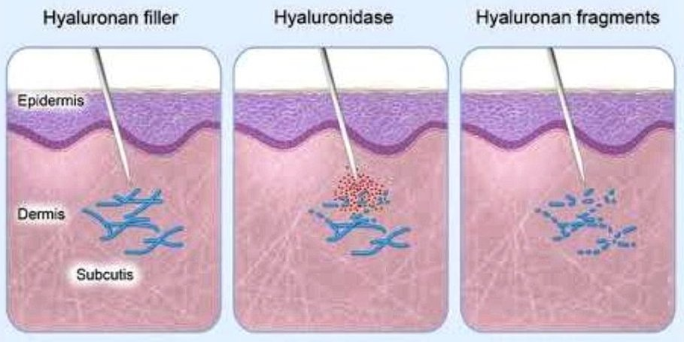

**Hyaluronidase (Hyalase®) Consent form**

Hyaluronidase is an enzyme that breaks down dermal fillers made of hyaluronic acid into small sugars which easily disperse.

**Risks of the procedure include but may not be limited to:**

Allergic reaction including anaphylactic shock which has a mortality rate 0.3 to 5% depending on the study. An allergy test can often identify this risk prior to full exposure. Local reactions are the most common, occurring about 1/100 Signs include oedema, erythema, pain and itching, urticaria and angioedema.

Hyaluronidase dissolves hyaluronic acid including molecules made by your body and previous treatments that you may wish to preserve could also me dissolved. You therefore could notice a reduction in skin elasticity and volume and associated asymmetry which typically would last a few days.

It is common to cause bleeding, bruising, some swelling or oedema and redness near the injection site. It is possible that the procedure will fail to remedy the problem ad there often HA is not the sole cause of lumps, bumps or reactions.

There is a small risk of introducing an infection, and a theoretical risk that pre-existing infection could spread further if hyaluronidase is injected into the area.

I confirm I do not have any known allergies to hyaluronidase, and to your knowledge you do not have any active cancers in the area injected and you are not pregnant or breastfeeding.

Notes:

____________________________________________________________________________________________________________________________________________________________________________________________________________________________________________________________________________________________________________________________________________________________________________________________________________________________________________________________________________________________________________

**Your Decision**

By signing this form, you agree that you have weighed up the side effects and risks and are aware of the contraindications of the treatment listed above. You have discussed the details important to you with your clinician. You agree that the balance of the benefits and risks to you overall favour the use of hyaluronidase.

Print Name: _______________________________________

Signed: _______________________________________ Date____________________

Clinician Name: ______________________________________

Signature: _______________________________________ Date____________________

**Hyalase® (Hyaluronidase) Injection Aftercare**

**Keep this aftercare leaflet safe and present it to the treating physician in the event of an adverse reaction**

Hyalase® is an enzyme which breaks down hyaluronic acid fillers, but it can also break down naturally occurring hyaluronic acid present in the body. The results can be unpredictable and the effect dramatic with possible loss of volume and some skin laxity. Although some of the effects can be immediate, it can take up to 2 weeks for the final results to be seen and the procedure may need to be repeated.

Hyalase® administration can result in anaphylaxis (a severe allergic reaction) which in itself is life threatening and requires immediate medical attention. Symptoms of a severe allergic reaction can include shortness of breath, wheezing, coughing, difficulty swallowing, swelling of the tongue, eyelids, lips, hoarseness of the voice, stomach pain, nausea or diarrhoea.

**If you have any of the above symptoms please report to your nearest Accident and Emergency Department or call 999 for an ambulance.**

After the procedure some other common injection-related reactions might occur. These reactions include redness, swelling, pain, itching, bruising and tenderness at the injection site. They have generally been described as mild to moderate and typically resolve spontaneously after a few days after injection. Bruising may occasionally be more significant.

*If you have any concerns following treatment, do not hesitate to contact us on <telephone number>. If this is outside of normal hours, please leave an answerphone message and we will normally get straight back to you.*

I have been treated with _____ Units of Hyaluronidase (Hyalase®) reconstituted in ____ mls of Saline / Water (delete as applicable) to dissolve a hyaluronic acid dermal filler. A skin patch test was administered to the left/right (delete as applicable) forearm. No sign of an allergic reaction was noted, and the procedure undertaken. Following injection, I was monitored for 60 minutes within the clinic.

**Date of procedure:**

**Amount administered:**

**Area treated:**

**Anaphylaxis**

Anaphylaxis is a severe and life-threatening, generalised or systemic hypersensitivity reaction. This is characterised by a rapidly developing and life-threatening airway with breathing or circulation complications usually associated with skin and mucosal changes. This is due to the release of inflammatory mediators and cytokines from mast cells and basophils, typically due to an immunologic reaction but sometimes non-immunologic mechanism.

Anaphylaxis is extremely rare in aesthetic medicine but is potentially fatal without immediate and appropriate treatment can lead to death. Therapists should be familiar with confidently recognising the symptoms of allergic reactions and anaphylaxis and have the appropriate equipment and medication to deal with it.

Anaphylaxis has been reported for dermal fillers, sclerosants (excluding hypertonic saline), topical anaesthetics and chemical peels.

**Signs and symptoms**

Anaphylaxis will typically present with many different symptoms over minutes or hours and has an average onset of 5 to 30 minutes if exposure is intravenous and 2 hours for food. The most common systems affected include the skin (80–90%), respiratory (70%), gastrointestinal (30–45%), heart and vasculature (10-45%) and central nervous system (10–15%).

Symptoms develop rapidly, usually within a few minutes, and must occur within an hour of exposure, and the symptoms can be life-threatening. Skin changes are often the first features and present in over 80% of anaphylactic reactions; they can affect skin, mucosa or both; however, skin and mucosal changes alone do not necessarily indicate anaphylaxis and can be subtle in up to 20% of cases.

**Airway and/or breathing problems**

* Swelling of the throat or tongue
* Difficulty in breathing or swallowing
* A sensation that the throat is is closing up.’
* Hoarse voice
* Stridor
* Shortness of breath
* Increased respiratory rate
* Wheeze
* Angioedema (swelling of the deeper tissues, e.g. eyelids and lips, sometimes in the mouth or throat)
* Client becoming tired
* Confusion caused by hypoxia
* Cyanosis can be a late sign.
* Respiratory arrest

**Circulation**

* Signs of shock (pale, clammy, trophic changes)
* Tachycardia
* Hypotension
* Decreased conscious level
* Angina
* Cardiac arrest

**Disability**

* Sense of impending doom.’
* Anxiety or panic
* Decreased conscious level caused by hypoxia or circulation problem

**Skin changes**

* Erythema (patchy or generalised red rash)
* Urticaria (also called hives, nettle rash, wheals or welts; anywhere on the body)

**Gastrointestinal problems**

* Vomiting
* Abdominal pain
* Incontinence

**Differential Diagnosis**

* Asthma can present with similar symptoms and signs as anaphylaxis, although asthma does not typically present with itching or gastrointestinal symptoms.
* Syncope or a vasovagal episode, although this tends to present with pallor rather than a rash.
* Panic attacks may cause flushing, but hives are not a recognised symptom
* Idiopathic (non-allergenic) urticaria or angioedema may occur.

**Minimising the risk**

Identify any risk factors by taking a full medical history, including a history of allergies and previous sensitivity reactions to cosmetic procedures or local anaesthetics.

Refuse treatment if a client has known or suspected sensitivity to ingredients in the product. Medical history forms specifically document the question identifying allergy to bee or wasp stings, but clients with an allergy to bees or wasps may be at risk of anaphylaxis to hyaluronidase, although the risks should be measured against the benefits. Sensitivity declines over time, so the last incidence should be noted. This particular allergy is only relevant for hyaluronic acid fillers should hyaluronidase be needed.

Latex gloves should be avoided as patients with atopic diseases such as asthma, eczema, or allergic rhinitis are at high risk of anaphylaxis from food, latex and radiocontrast, but not from injectable medications or stings.

**Treatment:**

Clients who have suffered anaphylaxis, even if their symptoms are improving, must go to the hospital for observation and further treatment if necessary. A period of in-hospital observation for between 2 and 24 hours is recommended for people once they have returned to normal due to concerns of biphasic anaphylaxis.

Biphasic anaphylaxis is the recurrence of symptoms within 1–72 hours with no further exposure to the allergen. Reports of incidence vary, with some studies claiming as many as 20% of cases. The recurrence typically occurs within 8 hours and is managed in the same manner as anaphylaxis.

It is recommended therapists download and print for display and easy referral the Resuscitation Council Algorithm; https://www.resus.org.uk/pages/anaalgo.pdf.

**Record Keeping**

Therapists should record:

* A description of the reaction, including timings, circumstances and presentation.
* A list of treatments administered
* Observations of vital signs.

Emergency services attending should be provided with all the above details to help with diagnosis and management.

**Reporting**

As a life-threatening event requiring hospital treatment, anaphylaxis is a reportable event. If related to a prescription-only medicine, it should be reported using the MHRA Yellow card scheme; it is to a dermal filler (a medical device) then report to the MHRA on the link below as well as reporting the reaction to the manufacturer and to your indemnity provider.  <https://yellowcard.mhra.gov.uk>

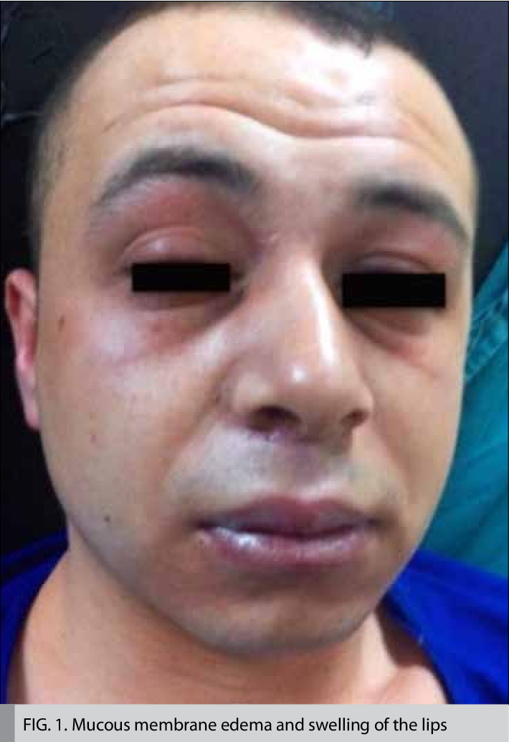

**Delayed Onset of Nodules**

A delayed onset nodule (DON) is a visible or palpable unintended mass that occurs at or close to the injection site of dermal filler.

Lumps, masses, nodules, regions of induration, delayed hypersensitivity reactions, biofilms, sterile abscesses and granulomas1 are all terms that are used to describe a delayed onset nodule. These categories are prone to substantial overlap, as reflected in the treatment options. A granuloma is actually a histological diagnosis, and no lump or nodule should be named as this unless there is histological evidence.

The risk of complication is greater for a less experienced therapist, and there needs to be a greater focus on anatomy, injection technique and product-specific variables. Improper injection technique can result in nodule formation, surface irregularities or overcorrection and asymmetry. Injection pressure, needle diameter and number, depth and angle of penetration sites can all be factors that may increase the risk of developing a nodule.

The increased immunogenicity of a product can increase the risk of a delayed onset nodule, and this is a function of viscosity, roughness, hydrophobicity, charge, particle size, particle shape as well as surface porosity.

Complications seem to occur more frequently with particulate fillers (combination gels); although any injected foreign body can elicit a reaction from the host tissue, the magnitude of this will depend on the nature of the product. The micro-particles of poly-L-lactic acid gel are likely to continuously provoke a host response as long as the degradation takes place and subunits are released, leading to a comparatively larger frequency of granulomatous nodules up to 14 months post-injection.

Delayed onset of nodules carries the potential to produce long-term disfigurement and dissatisfaction for the client. They tend to form in visible regions and can be difficult to conceal with make-up.

Select the correct product for the indication that you are treating. Always use a product that has evidence for its use and safety documentation. Ensure you receive your product from a trusted source and that it has been appropriately transported and stored.

The administration of dermal fillers requires an aseptic technique. A thorough cleaning followed by disinfection with 2% chlorhexidine gluconate in 70% alcohol, full removal of skin debris, thorough hand sanitation, and wearing sterile gloves.

Reduce trauma by using the correct gauge needle or cannula appropriate for the chosen product. Ensure injections are placed at the correct tissue depth and not too superficial and not intramuscular.

The periorbital region is a challenging area due to a combination of vascular factors, interpenetrating lymphatics, bony prominences, superficial fat compartments and a reduced skin thickness.

Lips appear to be more prone to developing nodules, possibly due to the thin mucosa, increased amounts of bacterial flora or the underlying hypermobile muscles, which can cause product clumping and extrusion.

**Treatment**

If a client develops a delayed onset nodule, the initial assessment needs to include the impact it has on the client. Some delayed onset nodules may be palpable within the skin but not visible, and they may be best left alone with regular observation for changes. Some nodules may be ‘disguised’ by the injection of dermal filler around the area. If the delayed onset nodules require treatment, the client needs to understand the risks vs benefits of treatment and the possible side-effects from intervention before making an informed decision and consent. Ensure good record keeping with photography.

A lump presenting at the time of treatment or within a few hours after is likely to be due to product misplacement, adjuvant anaesthetic or oedema. Massage by the therapist and the client should be the immediate response to an over-correction or product placed too superficially. This will lead to mechanical displacement and diffusion and may assist in reducing volume effects. Vigorous massage is of benefit and will help disperse the product.

Injection of lidocaine or saline along with vigorous massage can give a greater benefit even with non-hyaluronic acid fillers.

Lumps, masses or swelling, along with features of acute inflammation (redness, heat, tenderness, pain and swelling) presenting after 3-4 days and before 14 days, is likely to be due to infection and should be dealt with in the correct manner.

When a product is too superficial, or there has been an over-correction, early massage may help to smooth the skin and evenly distribute the filler. Small papules or nodules in the early stage may be aspirated with a 21G. If the cause is too much product or too superficial placement of a hyaluronic acid dermal filler, then this can be treated by the administration of hyaluronidase. Hyaluronidase should be used with caution if an infection is also suspected since this may lead to the infection spreading deeper into the tissue.

Capsular contracture around tissue fillers is rare but can occur; this is when a large bolus of filler has been injected, and a capsule develops around the surface exposed to the host tissue. This capsule subsequently contracts to create a nodule or a lump that can be painful. This can be treated by local anaesthetic and aspiration with or without hyaluronidase.

Delayed onset nodules present after weeks or months and may be divided into either non-inflammatory or inflammatory.

Non-inflammatory nodules are often cool, firm, discrete, with a regular surface and are likely to be due to product misplacement or migration and associated chronic immune-inflammatory reaction and possibly low-grade bacterial infection.

The initial management is with basic mechanical displacement and diffusion using saline and/or lidocaine, matching the volume of product injected which you wish to disperse.

Inflammatory nodules will usually show signs of pain, tenderness or redness.

Initial treatment should be with an antibiotic, either a macrolide (e.g. clarithromycin 500mg BD) or a tetracycline (e.g. minocycline 100mg BD or doxycycline 100mg BD) for two weeks and then review. It is important that the prescriber used is familiar and competent with prescribing oral antibiotics and aware of potential interactions, side-effects and contra-indications.

After two weeks, if there is a significant improvement, but it has not completely resolved, it would be advisable to continue the antibiotics for a further four weeks and then review. If there has not been any significant improvement, then dual antibiotic therapy may be prescribed.

If there has been no significant improvement after four weeks and the delayed onset nodule is a result of injection with hyaluronic acid dermal filler, then hyaluronidase may be considered.

Either mono or dual antibiotic therapy should be continued during this process at the judgement of the prescriber. If there has been a moderate to significant improvement with hyaluronidase, this can be repeated at four-weekly intervals until complete resolution or the client has received a satisfactory outcome. If there is no real improvement, the delayed onset nodule should be treated the same as a non-hyaluronic acid filler.

For non-hyaluronic acid fillers, inflammatory delayed onset nodules can be treated with intralesional steroid injection with good effect. Either mono or dual antibiotic therapy should be continued during this process at the judgement of the prescriber.

If there has still not been any significant improvement, then an expert in the management of delayed-onset nodules should be consulted, and the client referred over.

Throughout the whole process, the client should be kept fully informed and under regular review with good documentation and photography.

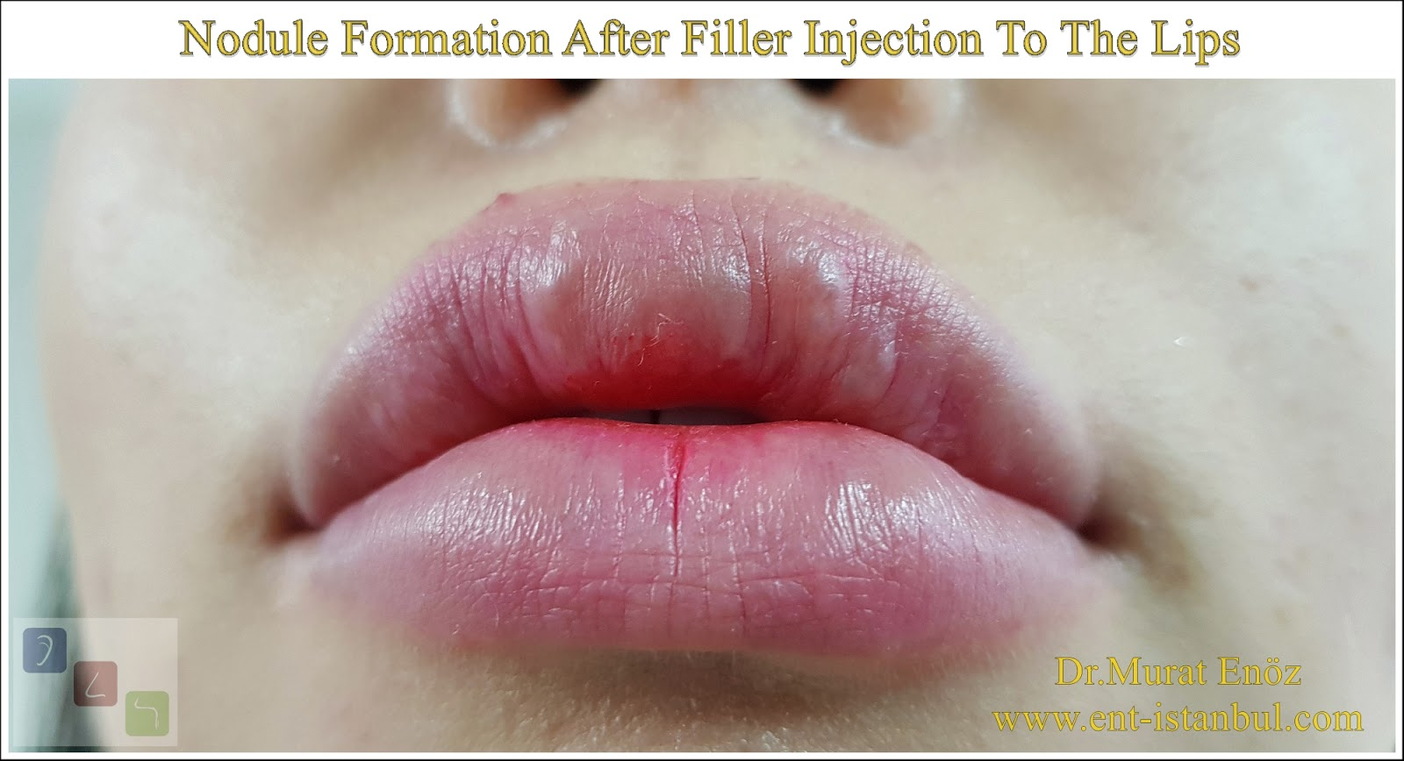

**Vascular Occlusion**

Vascular occlusions are the most severe and feared early complication in aesthetic treatments. There are several steps therapists can take to minimise this risk and identify the signs in order to treat this complication quickly.

A vascular occlusion occurs when blood is no longer able to pass through a blood vessel. It can be either a complete occlusion or a partial occlusion that results in a diminished blood supply. It may be caused by an internal obstruction such as a blood clot or a foreign body such as dermal filler that has either blocked or is compressing a blood vessel. If they are left untreated, a vascular occlusion can result in necrosis due to the lack of blood supply to the skin tissue.

Necrosis can be defined as" The death of most or all of the cells in an organ or tissue due to disease, injury, or failure of the blood supply."

Apoptosis, normal cell death is a programmed and ordered event, whereas; necrosis is the accidental death of a cell caused by insufficient supply of oxygen, thermal or mechanical trauma or irradiation. Cells that are affected swell and then burst (cytolysis), releasing their contents into the surrounding tissue. Necrosis results in a locally triggered inflammatory reaction that is characterised by swelling, pain, heat and redness. The necrotic cells are

subsequently phagocytosed and removed by the immune system.

**The three types of vascular occlusion associated with cosmetic injection are:**

1. Intravascular embolism
2. Extravascular compression
3. Vascular Spasm

When fillers are inadvertently injected into a blood vessel, the normal circulation can be impaired, which may lead to reduced tissue perfusion and compromise of the tissue relating to its angiosome.

Most dermal fillers used in cosmetic treatments consist of hyaluronic acid, and although hyaluronic acid is well-tolerated outside the vessel wall, it becomes highly inflammatory within blood vessels. This causes inflammation and spasm within the vessel, and this restricts the blood flow and dispersal of filler into the vascular system.

Many cases of vascular compromise will occur immediately with injection, and then the therapist must be aware of the signs of this.

**There are also incidents of delayed onset of vascular occlusions, and there are several proposed reasons for this:**

1. Dermal filler is hydrophilic (attracts water) due to the high contents of hyaluronic acid fillers. When the filler attracts these extra water molecules, this can lead to delayed swelling post-procedure and lead to external compression of a blood vessel.
2. A vessel may become obstructed by an embolus in an area of skin that has poor collateral circulation, and immediate signs of occlusion may fail to present during the appointment. As less nutrition is delivered to the skin over the following hours post-treatment, then signs of vascular compromiser may occur.
3. An intra-arterial injection may not show up straight away if it does not fully occlude the vessel. Hours post-procedure, this will lead to platelet aggregation, which will eventually lead to a full blockage.
4. Intra-arterial injections can initially occur in larger vessels or at a bifurcation point where it will remain initially but eventually become dislodged, leading to an occlusion in the terminal branch.

**Signs and symptoms of vascular occlusion**

**PAIN**

The client may experience severe pain at the time of injection. If local anaesthetic has been used either topically, administered with the product or as a nerve block, then this symptom may be less reliable.

If your client complains of sudden or escalating pain hours post-treatment, then the therapist should be aware that this may be a vascular occlusion, and a review of the client should be undertaken.

**BLANCHING**

When the vascular supply in an area is affected by a vascular occlusion, the area will often look paler than surrounding tissue, white or dusky due to the reduction in blood supply to the tissue. This colour will remain after the needle or cannula has been removed. Blanching may initially be transient and local; however, if this is not resolved, then the pattern of the blanching becomes reticulated or irregular and following the same path as the blood supply that is restricted. Blanching may be masked initially if topical anaesthetics or adrenaline-based products have been used.

**PURPLE DISCOLOURATION**

The skin may become purple or blueish in colour several hours after the treatment, and this is as a result of an accumulation of deoxygenated blood in the affected tissues. The appearance of this may look like a bruise; however, bruises will not blanch as they are caused by blood leaking into the skin.

**COOLNESS**

If the blood supply has been restricted to the area, then the tissues are not being perfused, so the temperature is reduced, leading to a cooler feeling of the area. This is not an immediate effect.

**How to minimise risk**

1. Therapists should have detailed knowledge and understanding of the anatomy in the area being treated. The distribution, as well as the depth of vessels of the treatment area and any possible variations, should be studied in depth.
2. A vein finder can be a useful tool to find and locate the blood vessel network beneath the skin prior to treatment.
3. Aspiration prior to injecting the filler to determine if the injection is intravascular. It should be noted that aspiration may not always be possible even if the needle is inside a vessel.
4. A slow injection technique under low pressure should be used to deliver the filler at an appropriate depth and tissue plane.
5. Inject the smallest possible volume of filler to achieve the desired result. Try to avoid overfilling an area. If more product is required, a repeat treatment can be undertaken 7-14 days later.
6. Avoid injecting in areas of previous scarring as arteries can fix into place by deep tissue scarring, making them easier to penetrate.
7. Bolus techniques should be avoided in areas at risk of vascular occlusions.
8. Avoiding the use of adrenaline helps you to identify blanching produced by occlusion much sooner.
9. Due to the fact many fillers contain an anaesthetic, it is harder to rely on the incident of pain to determine an occlusion.
10. The tip of the nose should not be injected as it is highly vascular in a restricted tissue space.
11. Caution should be observed when injecting into the glabellar region. Injections should be superficial (intradermal) and medially.
12. The use of blunt-ended cannulas of 25G is less likely to penetrate vessels and lead to an inadvertent intravascular injections. The risk of penetrating a vessel wall with a cannula more likely depends on the force used and the age of the client.
13. Clients that have undergone surgical procedures such as rhinoplasty as the anatomy and vasculature may be altered.
14. Always pay attention to your client when injecting to look for warning signs and listen to the client's feedback.
15. Higher density fillers have a higher risk of vascular occlusion as there is greater extrinsic pressure on the blood vessels.
16. Only reversible fillers should be considered, as this will make it easier to dissolve filler if anything goes wrong.

**Treatment of vascular occlusion**

**Immediately stop treatment**

As soon as you suspect a vascular compromise from any of the aforementioned signs, then the first step is to discontinue injecting further filler into the area and try to aspirate any product before withdrawing the needle or cannula.

Inform the client of the issue. If you are not confident in dealing with a complication, then you should seek the oversight of someone more senior or has the ability to oversee the complication.

Vascular occlusion will need prompt management as the risk of any tissue being damaged and the skin showing signs of necrosis increases over time.

1. **Access capillary refill time (CRT)**

Capillary refill time should be assessed on the effect as well as unaffected areas. Capillary refill time is the time needed by a distal body, such as a fingertip, to regain the original colour after it has been compressed.

A normal capillary refill time is around 2-3 seconds in clients under the age of 65 and 4 seconds for clients 65 years and over.

Capillary refill times that are longer than 3 seconds may be indicative of a vascular compromise. A fast capillary refill time on a background of bluish skin colour may indicate venous insufficiency.

It is good practice to test the client's capillary refill time prior to treating the client and recording this on their consultation form.

To check the capillary refill time, apply moderate pressure to the area for 5 seconds and then release. The time taken for the skin to return to its normal colour should be observed if the capillary refill is slow but not less than 3 seconds an initial attempt using conservative measures such as massaging the area, tapping or applying heat.

* Firmly massage the area using firm and prolonged strokes to encourage blood flow and try to remove any obstructions caused by the filler. Massage should be done for several minutes.
* The heat will encourage vasodilation and can increase blood flow to the area.
* Tapping over the area may also dislodge intra-arterial emboli either at the injection site or further up the vessel.

If capillary refill time is still not improving using conservative measures or the capillary refill time is longer than 3 seconds, then a high dose of hyaluronidase should be injected.

**Use Hyaluronidase**

Injecting hyaluronic acid fillers with hyaluronidase can relieve the problem before complications occur. Test patching is not required in a time-critical event when used for a vascular occlusion due to the risk of tissue damage is far greater than the risk of anaphylaxis.

**Aspirin**

Aspirin can limit platelet aggregation and clot formation as well as further vascular compromise. A dose of 300mg should be given immediately, followed by 75mg a day until the vascular occlusion has been resolved and there are no further contra-indications.

**Antibiotics**

If necrosis occurs, then there is an increased risk of a secondary infection. Topical or oral antibiotics may be required in order to promote healing and prevent any further complications.

Anti-herpetic medication might also be advised if necrosis occurs in a susceptible client in a perioral area.

If the vascular occlusion has been treated with no signs of skin damage, then antibiotics should not be given.

**Superficial Debridement**

If necrosis occurs, then a referral should be made to a plastic surgeon for removal of the dead tissue to allow for wound healing.

**Wound Care Management**

Apply appropriate wound dressings to encourage healing.

**Managing Pain**

Necrosis can cause severe pain. Some over the counter medication may be enough for some clients; however, some may require opioid analgesia.

**Refer**

It may be responsible practice to refer clients to other, more experienced therapists who have more experience in the management of vascular occlusions.

**Inform your insurer**

A vascular occlusion can be a distressing event for the client and the therapist. Regardless of how well the complication was managed, a claim may still ensue.

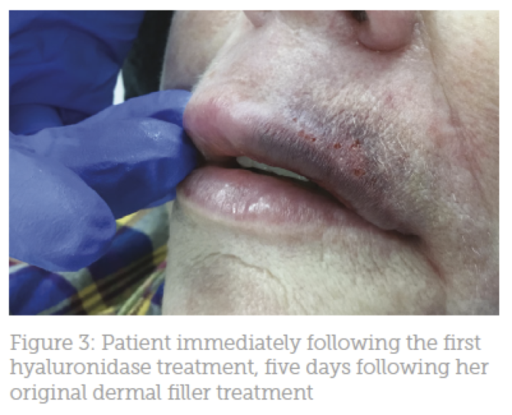

**Management of Necrosis**

Necrosis is the death of all or some of the cells in an organ or tissue due to disease, injury or a failed blood supply. Normal cell death is pre-programmed and does not result in triggering the same response in surrounding cells. Necrosis is an accidental death than can arise from trauma, lack of oxygen supply, thermal or mechanical trauma. Once the cell undergoes necrosis, they swell and burst in a process called cytolysis which releases their contents into the surrounding area. This results in the trigger of inflammation that causes swelling, pain, redness and heat. Necrotic cells are subsequently phagocytosed and removed by the immune system.

**Necrosis can occur due to:**

1. Interruption of the vascular supply
2. A vessel being compressed in the area
3. A foreign object is obstructing the vessel.
4. Tissue damage from physical, chemical, laser or radiation.

The signs and symptoms of necrosis were discussed earlier, along with the ways in which to reduce the risk.

The treatment for necrosis is the same as for vascular occlusion.

**Follow up**

All clients that have presented with necrosis will need a follow up until the problem has completely resolved, which may, in some cases, be on a day to day basis. An emergency out of hours number to the therapist should be available to allow the therapist to deal with complications immediately.

**Necrosis caused by sclerotherapy**

Around 1 in 100-500 cases or necrosis from an injection of sclerosant have been reported when performing sclerotherapy. This is far higher than with dermal filler. Necrosis can occur as a small area of an ulceration that heals completely without scarring, or it may be more severe and result in tissue death. It can arise from the displacement of a sclerosant into an artery or arteriole, placement outside the intended vein or due to excessive injection pressure.

The sclerosant used can have an impact on the incidence of necrosis, and some clients will be at a higher risk, especially smokers and those on certain medication or with underlying health concerns.

The presentation will be the same as previously described, and symptoms will present as pain, pale looking skin and discolouration, all occurring within the first 24 hours post-procedure. Dermal sloughing can occur within 24-72 hours after the ischaemic event, and an ulcer will develop.

Treatment will include measures to improve the prefusion to the area, compression and occlusive dressings. If wound infection occurs, then antibiotics may be required. Appropriate wound management that includes superficial debridement may also be needed. Once the area has fully healed, dermal scarring can be treated.

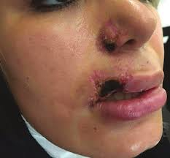

**Prevention and treatment of ecchymosis (Bruising)**

An ecchymosis is also known as a contusion or bruise. It is a small haemorrhagic spot caused by the extravasation of blood. It is seen clearly in the skin and mucous membrane and prevents as a non-elevated, rounded or irregular, blue or purple patch.

Bruising is the most common side-effect of aesthetic treatments and is thought to occur in around 19-24% of clients.

Clients that are embarrassed or perhaps cautious of others being aware that they are having aesthetic procedures may need to be made aware of this risk. Clients may choose to book an appointment when they are off work or when they are able to take some downtime.

Certain factors can increase the risk of bruising, and a full medical history of the client should be taken prior to treatment. This may also include references to previous treatments and their susceptibility to bruising, haematological and liver disease, medication and over the counter drugs that they are currently taking. Older clients with thin and more fragile skin have slower repair mechanisms and are therefore more likely to bruise and will be slower to recover. Consumption of alcohol will also increase the clotting time and increase the clients risk of bruising. If the client is malnourished or has a vitamin C or iron deficiency also have an increased risk of bruising and a more prolonged healing time.

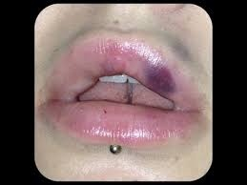

Certain medications affect the blood clotting process and can increase the risk of haemorrhage and bruising. Some of these include:

* Aspirin
* Clopidogrel
* Warfarin
* Non-vitamin K dependent oral anticoagulants such as;
  + Dabigatran
  + Apixaban
  + Rivaroxaban
* Heparin

The above medicines are usually prescribed in atrial fibrillation, thromboembolic disease, mechanical heart valves and clients with a high risk of or previous cardiovascular or cerebrovascular infarction. Medicines should not be stopped without prior advice or consultation with the clients GP.

Other medications that increase the risk of bruising include:

* Non-steroidal anti-inflammatory medications such as;
  + Ibuprofen
  + Naproxen
  + Diclofenac
  + Celecoxib
  + Meloxcam
* Corticosteroids
* Any prescribed medicine that may have side effects pertaining to bruising.

Over the counter herbal and vitamin supplements may also increase the likelihood of bruising and influence clotting time. They include:

* Fish oils
* Omega-3 fatty acids
* Garlic
* High dose vitamin E
* Gingko Biloba
* St. John’s Wort

The above should be stopped at least two weeks prior to treatment.

The therapist should also have a good knowledge and understanding of venous and arterial vessels of the face to avoid puncturing larger vessels. The skin should be inspected after removing the makeup to identify any superficial vessels which you will need to avoid. Good lighting is essential, and other aids such as a magnifying lamp or glasses and a vein finder may put you at a better advantage. The treatment room should also be cooler, as this will reduce vasodilation.

 Always ensure the client is positioned correctly, as this can reduce unnecessary trauma. Keeping the non-injecting hand firmly on the area to keep the head braced in position to reduce movement.

Fanning or threading techniques into the dermal or immediate subdermal plane with sharp needles are more likely to result in bruising than using single injection techniques. The depot or aliquot techniques with product places at the supra-periosteal levels are more likely to reduce the incidence of bruising.

Using larger gauge needles will also increase the risk of bruising as they are more likely to damage blood vessels. The smaller the gauge used will reduce bruising.

Evidence has shown that using a fanning technique with a blunt-ended cannula can also reduce the risk of bruising; however, very thin cannulas can still cause trauma. As cannulas are longer than needles, they will need far fewer entry points and will minimise further risk.

Treatments that are performed slowly with less volume will have a better outcome for reducing the risk further.

The therapist may wish to cool the skin prior to treatment using a cooling device to reduce the risk by 60-88%.

The use of adrenaline (epinephrine) with lidocaine leads to vasoconstriction and inhibits the activation of eosinophils which leads to bruising. However, the use of adrenaline can mask the signs of vascular occlusion, so it should be used with caution.

Always inform the client of the risk of bruising and that dependent on the area, this may look like a black eye etc. Bruising usually resolves within 14 days but may persist for longer. The client can apply cold packs within the first 48 hours, followed by heat to aid the healing process.

Applying compression after injecting will also reduce the risk of bruising, as do cold compresses and the topical application of arnica, vitamin K or bromelain, and this can all lead to a reduction in the development of a bruise. Bromelain, which is an enzyme derived from pineapple, can also be taken at a dose of 200-400mg three times a day to speed up the healing process.

Clients should be advised to stay out of the sun to limit the risk of persistent staining.

Vigorous exercise can also increase the risk of blood pressure and further aggravate the bruise that is developing. Clients should also avoid extreme heat.

**Haematoma**

Sometimes a haematoma may form rather than a bruise. This is a collection of blood under the skin or within the muscle, and this may become trapped and result in a firm mass appearing. Blood within the haematoma is initially liquified and can be aspirated or drained and dealt with before it becomes solid. Haematomas always resolve on their own over several weeks as the body breaks them down through normal processes. Haematomas are very rare after an aesthetic procedure. If they are very large, they are capable of causing damage to surrounding tissue due to compression; then, they may be removed surgically.

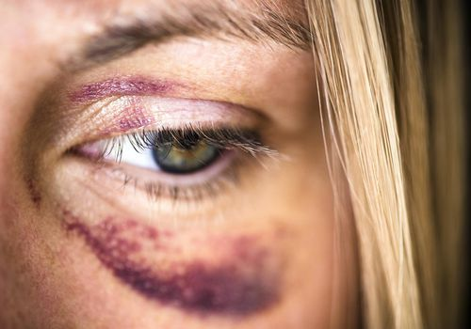

**Managing acute skin infections**

An infection is caused by an invasion of multiplication of microorganisms in the tissues of the body, especially that causing local cellular injury due to competitive metabolism, toxins, intracellular replication or antigen-antibody response.

An acute skin infection may occur after any treatment where the integrity of the skin has been breached. This is usually after an intradermal injection such as dermal fillers, botulinum toxin treatments, sclerotherapy and micro-needling. Infection can also likely occur after non-penetrating procedures such as chemical peels or thermal damage caused by lasers or IPL.

Infections are extremely rare and depends on multiple factors relating to the client, the therapist and the procedure itself.

Infections are likely to occur because of the contamination at the time of injection due to lack of or poor disinfection or injecting through infected sebaceous glands, reduced skin immunity or bacteraemia at the time of injection.

**Signs and symptoms**

Skin infections such as cellulitis or erysipelas will present with redness, heat, tenderness and potential swelling. The infection is initially localised, but if this isn’t treated quickly, it can spread and lead to blisters or bullae over the infected site. The client may have systemic symptoms such as fever, malaise, nausea, rigours and sweats. Acute infections have rapid onsets and will present within 3-7 days of treatment.

The client should be checked to assess if they have an early infection which can be sometimes difficult to differentiate from initial inflammation caused by the treatment, necrosis or an allergic reaction.

Delayed onset infections can occur several weeks or years after the initial injection and should be suspected if a red, indurated area presents any time after infection.

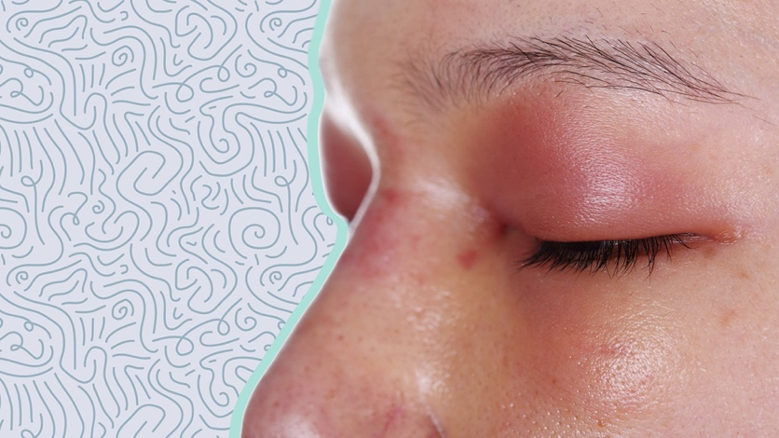

**Minimising the risk**

**CLIENT**

Take a full medical history and perform a full examination of the client. There are contra-indications for all treatments, and any condition which impairs immunity is a risk factor for skin infections.

Relative contraindications include:

* Diabetes mellitus
* Immunosuppression (acquired or drug-induced)
* Obesity
* Venous insufficiency
* Oedema of lymphoedema
* Dental infection
* Poor oral hygiene
* IV drug use

Treatment should not be carried out in an area where a pre-existing infecting is present or is the client has a systemic infection.

Medication may increase the risk of infection due to drug-induced immunosuppression, including steroids, chemotherapy agents, anti-rejection drugs and disease-modifying drugs, such as methotrexate, azathioprine, leflunomide, ciclosporin, mercaptopurine and mycophenolate.

Always inform the client of the risk of bruising during the consultation process and give written aftercare advice to take away on what to look for and what to do if symptoms develop.

**THERAPIST**

Therapists should have a good understanding of the risk of infection and how to manage infection control which must be in-line with professional standards and their code of conduct.

**ENVIRONMENT**

The environment that you are working from should be suitable for carrying out aesthetic treatments and compliant with infection control standards. The area should be clean and hygienic with handwashing facilities. The use of sterile packs and drapes are recommended.

**PRODUCT**

Use only legitimate products where the source can be identified. Products should always be used within their expiry date or discarded immediately. Products from single-dose syringes should not be administered to multiple clients, even if the needle has been changed. Needles, syringes and cannulas are all sterile, single-use items. Ampoules, vials or single-dose products should not be used on multiple clients. The leftover product should always be discarded.

Reconstitute using aseptic techniques as per manufacturers guidelines. If multi-dose vials are used, then both the needle, cannula or syringe used to access the multi-dose vial must be sterile, and the cap disinfected prior to penetration. Multi-dose vials should be discarded within 28 days unless the manufacturer states otherwise.

**TECHNIQUE**

Good skin preparation is essential. All makeup should be removed along with other potential contaminants using a facial wash and followed with an antiseptic skin preparation of the treatment area using 2% chlorhexidine and isopropyl alcohol 70% if no history of sensitivity or a hypochlorous solution. Skin disinfection should be done after the makeup has been removed and before the application of ice.

The disinfection of skin should be applied using a gentle friction motion, repeatedly moving up and down and back and forth for around 30 seconds to reduce the number of resident bacteria present at the treatment site. The solution should be allowed to fully dry.

An aseptic technique that includes good hand hygiene should be adopted. The use of gloves is recommended, and the needle or cannula used should not be contaminated during the procedure by placing it down on an unclean surface. Do not wipe excess product off the needle with gauze; residual amounts can be flicked off.

**AFTERCARE**

Clients should be advised to avoid touching the area for 4 hours after the treatment and to not apply any makeup for 12 hours. Hand gel can be applied to clients hands straight after the treatment in case of an incident where they do touch the area.

**AREAS OF CAUTION**

Periorbital cellulitis should be considered an emergency as there is a potential risk of orbital spread and subsequent blindness. Clients should be referred to a specialist.

Clients should always be informed of the risk of infection, along with the symptoms they should look for. They should report to their therapist if they notice any erythema, heat, tenderness and/or swelling in the area that is not settling within the first 48 hours of the procedure. If the therapist is not available, the client should seek medical advice.

Non-prescribing therapists should refer to their prescriber immediately for diagnosis and treatment. The clients GP should be notified in accordance with professional standards and good medical practice with the consent of the client.

A prescriber or the clients GP may prescribe a course of antibiotics to help reduce and clear up the infection.

**Prophylaxis and treatment of herpetic infections**

The herpes family of viruses include herpes simplex virus 1 and 2 (HSV-1 and HSV-2), Herpes Zoster Virus (HZV), Epstein-Barr Virus, Cytomegalovirus (CMV) and Human Herpes Virus 6, 7 and 8.

After the initial infection, the virus will lie dormant in the dorsal root nerve ganglion and can reactivate at any time throughout the client's life. Reactivation can be triggered by local trauma, systemic stress, mental tension, fatigue or exposure to bright light. Damage caused to the nerve axon by a needle during an aesthetic procedure can also trigger the reactivation of the virus. Tissue manipulation, dermal injury and inflammatory reaction can also play a role in the process. It has been demonstrated, however, that in the case of dermal fillers, the hyaluronic acid acts as a protective agent and prevents viral replication.

Around 3.7 billion people (67%) have HSV-1, and 417 million people (11%) are estimated to have HSV-2 infections. However, the incidence of HSV-1 reoccurring after dermal filler is thought to be as low as 1.45% of cases, and herpes zoster is even rarer.

**Signs and symptoms**

The presence of a cold sore after an aesthetic procedure can be upsetting for a client due to the discomfort and obvious physical appearance of the sore. Signs and symptoms are likely to appear around 24-48 hours after treatment, initially as neuralgic pain or a tingling sensation. Signs of pruritus and dysesthesia may also be present. This may be followed by general malaise or fever and last for 6-48 hours. HZV will appear as vesicles or blisters in a unilateral dermatomal distribution, whereas HSV will be bilateral and may appear in several distinct areas. Herpetic lesions appear initially as thin-walled intra-epidermal vesicles, which subsequently burst, crust and heal. They are typically circular ulcerations covered by the yellowish film with surrounding erythema, and there is some weeping from the ulcerations. The reoccurrence of symptoms are usually mild and will heal within 5-7 days without scarring.

The appearance of a herpetic outbreak may be confused with a bacterial infection such as impetigo, so it is important that the correct diagnosis to enable the complication to be treated effectively.

If blistering occurs outside of the areas typical of herpes eruptions or in a high-risk area for necrosis, then vascular compromise should be excluded. Skin necrosis will usually be immediate or within hours of the treatment, whereas herpetic infections appear days later.

Virus reactivation generally occurs in the area that has been treated, but it can affect the neighbouring areas, and the most common sites are the perioral area and nasolabial folds.

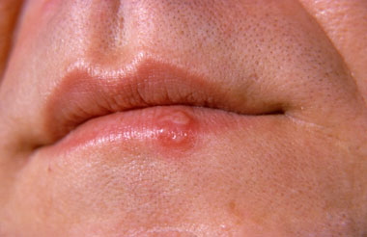

**Minimising Risk**

A full client history should be taken prior to treatment, and a record kept of any previous herpetic outbreaks, including cold-sores (HSV) and shingles (HZV), frequency of attacks and any personal triggers. If the immune system of the client is also compromised, then it is likely that this will increase the risk of a reoccurrence. Prophylaxis or abandoning the treatment are considerations worth making,

Anti-HSV prophylaxis is recommended with CO2 laser resurfacing, even in patients with no history of HSV.

Guanine nucleoside analogues, such as acyclovir and valaciclovir, are antiviral drugs that inhibit viral replication and are converted into their active drug component within an infected cell by the action of a viral thymidine kinase. Most viral replication occurs within the first 24 hours of infection, so prompt treatment at the prodromal stage, prior to lesions erupting, is recommended to limit epithelial damage and possible secondary complications.

When a client reports a cold sore eruption following a low risk, non-invasive procedure, the client should be given advice on managing symptoms and preventing spread and auto-contamination. If symptoms worsen or do not improve significantly in 5-7 days, the client should be reviewed and referred to exclude other conditions affecting immunocompetency.

Be aware that herpetic eruptions may also develop secondary bacterial infections and require topical or systemic antibiotics in addition to antiviral treatment. The initial presentation may even be impetiginised due to secondary bacterial infection and require dual therapy at the outset.

If there is any ocular involvement, an urgent opinion from an Ophthalmologist is essential as rarely surgical debridement of the cornea may be required17.

**Prophylaxis**

There are no randomised controlled trials to indicate an optimum time to commence episodic prophylaxis. Consensus dictates treatment should not commence two days prior to treatment and no later than the day of treatment and continue for five days or until the skin has healed.

If the client suffers a recurrence despite prophylaxis, consider prolonging the treatment course.

Provide self-help advice on the prevention of auto-inoculation and transmission to others.

Review if symptoms do not improve or worsen after seven days and consider referral to their General Practitioner for further investigation.

Prophylactic treatment is recommended in the following circumstances:

* Three spontaneous eruptions per year
* Previous eruption at any time because of a procedure
* Lip augmentation and previous HSV eruption at any time
* Facial resurfacing procedures, such as non-fractional laser resurfacing and deep chemical peels.
* Immunocompromised
* Immunosuppressed

Oral antivirals do not prevent the progression of latent infection.

**Follow-up**

All clients presenting with a herpetic eruption post-procedure should be supported to manage their condition, carefully followed-up, and photographs should be taken to objectively assess over time. If the therapist is unable to prescribe the required treatment or has been unsuccessful in dealing with the complication, it is important to make an onward referral to a practitioner who has more experience in this area.

**Management of Tyndall Effect**

In aesthetics, the Tyndall effect is used to describe the bluish hue that is visible within the skin caused by too superficial placement of hyaluronic acid (HA) filler. This side effect of the treatment is more commonly referred to as the Rayleigh scattering by physicists after Lord Rayleigh, who studied this process in more detail. Different wavelengths of light do or do not scatter depending on the size of the substance that they encounter. Blue light is scattered around ten times more than red light when passing through very small particles. This is the reason that the sky appears blue and that a pool of hyaluronic acid underneath the skin scatters more light of a shorter wavelength and has a bluish discolouration. The greater the number of small particles within a substance, the greater the scattering and the more obvious the discolouration.

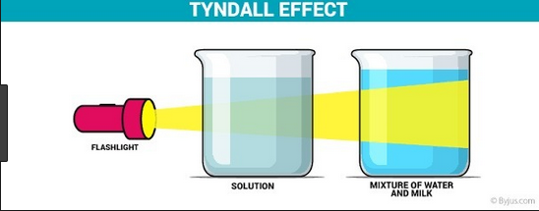

**Signs and symptoms**

The Tyndall effect occurs if hyaluronic acid is placed too superficially or in large boluses and may be mistaken for a mild but deep bruise. The area may also be slightly raised or lumpy because of the superficial placement. The discolouration may be difficult to see in poor lighting. This can give a poor aesthetic outcome that leads to client anxiety and dissatisfaction. The Tyndall effect may appear immediately after the treatment or within a few days, and without correction, it may last for months or even years.

The Tyndall effect is more likely to occur in areas where there is thinning of the skin. The tear trough and perioral or smokers lines are more common sites to see this complication.

**Minimising the risk**

The consultation process should include discussion on the risks of the client developing the Tyndall effect after the procedure when using hyaluronic acid-based fillers. Avoid treating high-risk areas if the skin is already thin and compromised.

Correct technique is vital to preventing this type of complication, and the depth of the injection is paramount to avoiding the appearance of the Tyndall effect. For example, injection into the tear trough region, the filler should be placed at the periosteal level or at least the sub-orbicularis plane. Injecting smaller amounts of filler can also reduce the risk, as well as avoiding larger bolus injections in areas of caution.

Some products claim that they reduce the effects of the Tyndall effect due to their molecular structure, the use of cross-linked with non-cross-linked hyaluronic acid in combination with amino acids and minerals. It is believed that dermal fillers with large particle sizes are more likely to develop the Tyndall effect.

**Treatment of Tyndall Effect:**

The area should be massaged firmly to sufficiently flatten and disperse any excessive product, superficial placement or a poor aesthetic result of the filler. Massage is the most effective treatment if it is done as soon as the effect is noticed and ideally at the time of treatment. The longer you wait, the less likely that massage will be successful.

.

Excision of the product from the area using and 18G needle and expressing the filler out the area may be successful. Aspiration with a needle and syringe can also remove the filler.

The Tyndall effect can also be removed by dissolving the filler using hyaluronidase. This will usually resolve the issue within 24 hours, although a second treatment may be required. The dosage will vary depending on the filler used and the area being treated, and whether the client consents to the filler being removed. Around 30-75 units are suggested doses to be used.

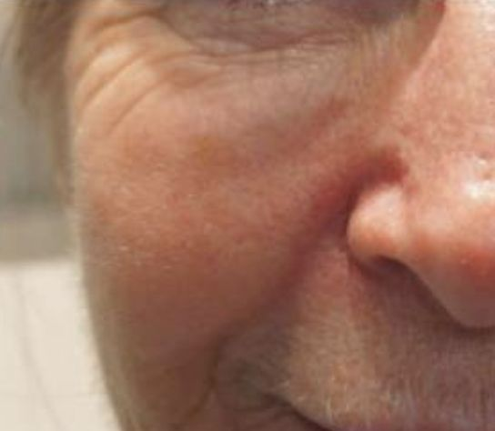

**Follow-up**

Clients should be followed up and photographs taken to assess the treatment and healing response over time. If the therapist is unsuccessful in treating the complication, then the client should be referred to another professional who has more experience in complications.

**Managing oedema**

Oedema is the accumulation of an excessive amount of serous fluid in or around the cells, tissues or serous compartments of the body. Oedema can be localised to a region or more widespread and can be caused by various triggers such as trauma, medication or systemic illness. Lymphoedema occurs because of obstruction of lymphatic vessels or lymph nodes and the subsequent build-up of lymph in the affected region.

Angioedema is the rapid swelling of the dermis, subcutaneous tissue and mucosa. It can be severe and life-threatening and should be treated as a medical emergency, although angioedema following dermal fillers is extremely rare. Less severe cases can cause swelling, which can last several weeks; this may be just present at the treatment site or maybe more generalised.

A very common side-effect with aesthetic treatments is usually mild and self-limiting. Clients should be informed about the risk of oedema and swelling prior to the treatment. The onset of oedema depends on many factors:

* Clients age
* Lifestyle factors
* Medical conditions
* Pre-existing lymphatic compromise
* Medication
* Type of product used, the area treated, and volume injected
* Trauma from the treatment process

**Signs and symptoms of oedema**

Oedema is recognised by the presence of swelling within or underneath the skin. It may be pitting where it holds an indentation after pressure is applied and non-pitting where the swelling springs back into place after pressure has been applied. If the area is red and warm, then the infection may be the cause.

Oedema can occur anywhere that the treatment has been performed; however, some areas are more prone to swelling, such as the lips, periorbital and malar regions. Some hydrophilic fillers can make tissue oedema more pronounced, and the therapist should be cautious to ensure that they do not confuse oedema for dermal filler in asymmetries.

**Minimising the risk**

**TAKE FULL MEDICAL HISTORY**

Take a full client medical history prior to treatment to find out any pre-existing conditions, medications, and other supplements that they are taking that may increase their risk of oedema.

The client should have the risks fully explained to them before starting the procedure, including what side effects are likely to occur and how they can manage them.

**PRODUCT**

Choose the right product for the indication that you are treating in accordance with the manufacturer's guidelines.

Due to the hydrophilic nature of hyaluronic acid, some brands can cause more oedema that others.

**TECHNIQUE**

The less trauma caused during the procedure will reduce the risk of swelling. Oedema is more likely to be worse where fanning techniques have been used, or large volumes of filler have been injected in one area or injecting too quickly.

Injecting anaesthetic into the area can also increase the risk of oedema and asymmetry.

Gently massaging the area after the treatment as vigorous massage can increase tissue trauma and swelling.

**MANAGING OEDEMA**

Ice can be applied to the area to help reduce reactions such as swelling, tenderness and redness.

Avoid extremes of temperature or altitude within the first 48 hours to limit the persistence or oedema.

Hyaluronic acids with high molecular weights and less cross-linking are more likely to cause oedema.

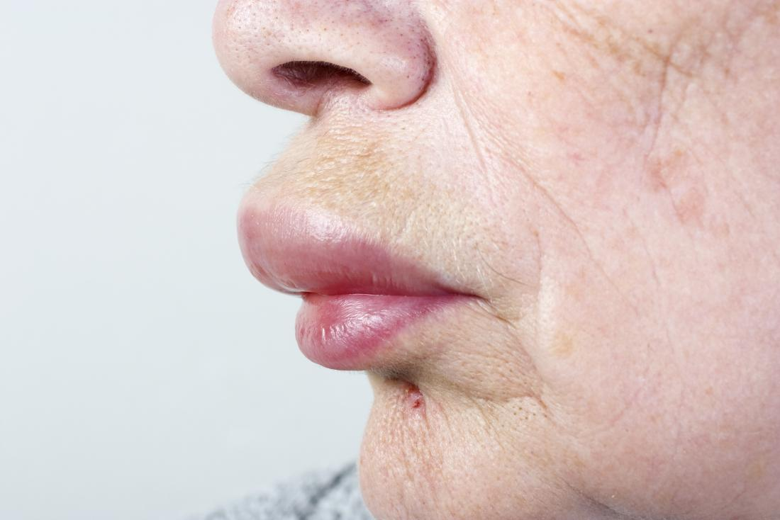

**Malar Oedema**

A collection of fluid in the infraorbital region is known as malar oedema and is a common complication form dermal filler injections into the tear trough and can last around five months. It may also occur from other treatments in the area, such as chemical peels, laser treatment and carboxytherapy.

Due to the connective tissue septum, the superficial fat compartment has a compromised lymphatic drainage and is the reason the eyes become puffy after a poor night’s sleep or crying. This is different from other rather impenetrable malar septum, which divides the superficial suborbicularis oculi fat into a superficial compartment.

Injection of filler into the superficial malar septum can further impede lymphatic drainage and produce malar oedema. Injecting too deep or using too great a volume with a viscous product can cause compression of the lymphatic vessels.

The risk can be reduced by selecting the correct clients who do not frequently suffer from puffy eyes, using a filler of low elasticity and viscosity and limiting the volume that is injected and only injecting either supra periosteally or at the immediate subcutaneous level above the area prone to lymphatic compromise.

Treatment of malar oedema includes head elevation, application of cold compresses, manual compression and lymphatic drainage several times a day along with a course of steroids. If the complication does not resolve, then hyaluronidase may be used.

**Treatment of oedema**

**UNDER 2 WEEKS**

Oedema often settles on its own within a relatively short time. Ice packs are used by many therapists, although this has not been proven to reduce swelling. Gently massaging the area can help improve lymphatic drainage, and this can be done by the client at home. The reassurance of the client is required. Clients may choose to take ibuprofen to help relieve the inflammation.

If oedema is quite severe oral steroids have been prescribed, but there is little evidence to support that this helps. A single intravenous bolus of 1g methylprednisolone given intra-operatively during facial surgery has been found to reduce oedema with a shorter duration of swelling.

Oedema can arise due to an antibody-mediated Type 1 hypersensitivity reaction. This usually develops quite quickly after treatment and is due to exposure to the tissue of foreign material, for example, dermal filler. Swelling can be localised or generalised and mild or severe. IgE starts an inflammatory cascade and mast cell degranulation which leads to the release of histamine, cytokines, prostaglandins, leukotrienes, heparin and proteases, which result in the onset of oedema, erythema, pain and itching. Swelling and inflammation normally settle down in a few hours to a few days but, in some cases, can last for a few weeks if the reaction to the filler is ongoing. Initial treatment involves anti-histamines such as loratadine or cetirizine 10mg once a day. Oral steroids may be required in there is significant swelling or discomfort.

If swelling lasts longer than two weeks or for several months, then it is essential to try and identify the cause of swelling rather than treat the swelling in isolation. Superficial product placement can be misdiagnosed as oedema. Hyaluronic acid also attracts a large amount of water which can also give the appearance of swelling. Treatment should be the same as dealing with incorrectly placed filler to improve oedema.

Delayed onset of facial oedema can develop several days to weeks after treatment which may be caused by a Type IV hypersensitivity reaction. These are characterised by T lymphocytes rather than antibodies and will present with induration, erythema and oedema. These reactions will not respond to anti-histamines and will need to be treated with oral steroids. As the hypersensitivity is usually long-lasting, the client will be usually prescribed a loading dose of steroids with a tapering off regime to the lowest dose that will control symptoms (e.g. prednisolone 40mg a day for one week then reduce by 5mg every few days until symptoms are controlled at the lowest possible dose, usually around prednisolone 5mg). As there are risks and other considerations associated with long term steroids (including gastric ulceration and osteoporosis), often the best course of action would be to remove the underlying problem and dissolve hyaluronic acid filler with hyaluronidase.

**Follow-up**

All Clients that present with significant oedema should be followed-up, and photographs should be taken to document and assess the swelling over time. If oedema persists for over six weeks and intervention has not been successful, it would be sensible to consider referral to a professional who has more experience in this area.

**Managing Ptosis**

Ptosis is the medical terminology that describes the drooping or abnormal lowering of an anatomical area. Ptosis is derived from the Greek word for falling. The terminology for eyelid drooping is more accurately referred to as blepharoptosis.

This is a complication that is exclusively inadvertent to the injection of botulinum toxin type A into an unwanted area that results in muscle weakness and a persistent droop. Ptosis can affect the brow, which results in the lowering of the eyebrows, which may, in some cases, affect vision. Upper lid ptosis may occur when the injector is treating the glabellar complex, and botulinum type A diffuses through the orbital septum and affects the lid elevator muscle either as it traverses the pre-periosteal plane, or the toxin may travel along the tributaries of the superior ophthalmic vein. This can result in a drooping of the upper eyelid, and the client may be unable to fully open their eye.

Although ptosis may persist for the whole duration of the effect of the treatment with botulinum toxin type A, it will usually settle more quickly, and eyelid ptosis will often settle within 3-4 weeks and brow ptosis within six weeks.

**Signs and symptoms**

The client will normally be effected within 3 – 7 days post-procedure, complaining of a drop of the brow or eyelid. Ptosis can be unilateral or bilateral. Sometimes the ptosis is subtle, and although it may not be immediately apparent, the client will feel that the lid or brows feel heavy, and they may not be able to fully open their eye and may struggle to put on their eye makeup.

**Minimising the risk**

Undertake a full medical history, including any pre-existing conditions and obtain consent after advising on the risks of side effects and complications, including potential for ptosis. Next, assess the patient's anatomy and musculature, pay particular attention to the brow position (the anatomical brow rather than the actual brows which may have been cosmetically altered) and any pre-treatment asymmetry. Assess brow size and heaviness with particular attention to the resting tone of frontalis to ensure that the client is not using this muscle at rest to support the brows (ask the client to sit upright, look forward and then to close their eyes, if the eyebrows descend during this check, do not treat the forehead lines). Photographs should always be taken prior to treatment. Post-treatment, inform the patient to avoid sunbathing, saunas and massage for at least 4 hours which may lead to a greater spread of the toxin.

**Brow ptosis**

Brow ptosis can be reduced with a few simple rules.

1. When treating the frontalis muscle, always inject at the mid-forehead or above (at least 2cm above the brow in all clients and for older clients, ensure injections are at least 4cm above the brow).
2. By injecting intradermal rather than intramuscular when treating the forehead, a study has reported a lower incidence of ptosis with no reduction in results.
3. Always inject the glabellar at the same time as the forehead (never treat the frontalis muscle in isolation), particularly in clients over 50 years of age (treating the brow depressors at the same time as the elevator muscle) and if the therapist anticipates problems with the forehead, it is recommended to inject the glabellar first and then reassess the forehead in 2 weeks. As with all botulinum toxin type A treatments, if in doubt, use conservative amounts and reassess the need for additional units at the review.
4. Be cautious in any client who has had previous frontal facial surgery.

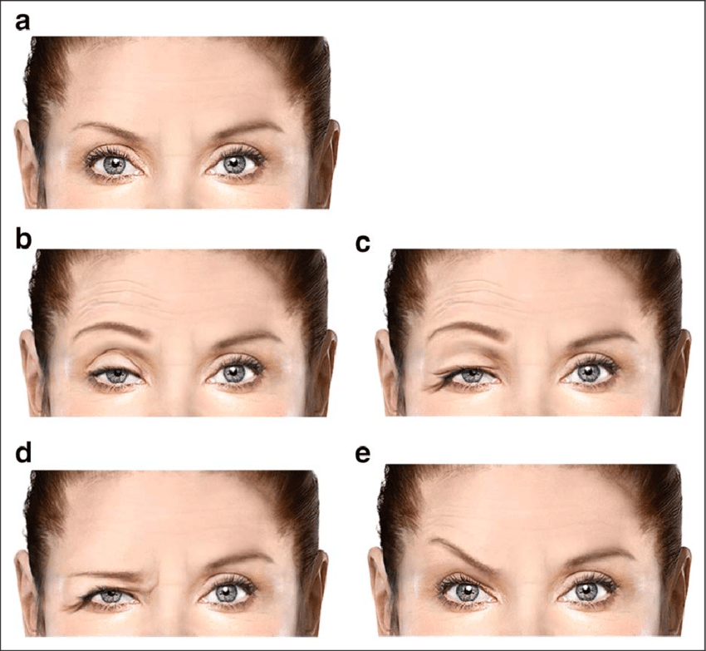

**Eyelid ptosis**

1. Injections should always remain 1cm above the brow and not lateral to the mid-pupillary line when treating the glabellar.
2. During injection of the corrugator supercilii muscles, use digital pressure over the supraorbital rim with the non-injecting hand to reduce the risk of diffusion.
3. When injecting around the glabellar complex, the needle should be pointing superiorly away from the orbit.
4. When treating under the eye during the treatment of crow’s feet, the botulinum toxin type A should never be injected medial to the mid-pupillary line and must remain at least 1cm away from the margin of the orbit. Never inject immediately below the eye if there is a significant degree of scleral show pre-treatment, if there has been previous eye surgery or if there is a negative snap-test (eyelid extraction test) with a delay in the skin below the eye returning to its normal position after being manually pulled down.

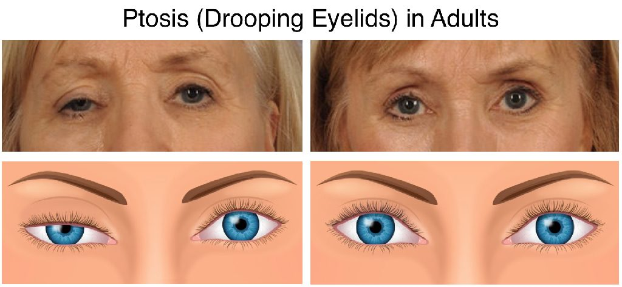

**Lip ptosis**

1. When treating the crow’s feet, ensure injections remain within the confines of the orbicularis oculi muscle. If treating too inferiorly, it is possible that the zygomaticus major muscle may be affected. This muscle arises from the anterior zygoma and is responsible for lifting the corner of the mouth up and laterally. Ptosis in this area becomes more apparent when the client is asked to smile.
2. Lip ptosis can also occur when treating smoker’s lines and over-administration of botulinum toxin type A to the orbicularis oris muscle. Only small doses are required in this region, and they should only be performed by experienced injectors.

**Treatment of ptosis**

Stimulating the muscle can help to lessen the duration of the ptosis; this can be done by exercising the muscle or through electrical or mechanical stimulation. The back of an electric toothbrush can be used for several minutes a day.

If upper eyelid ptosis requires treatment, 0.5% apraclonidine eye drops can be prescribed at a dosage of 1-2 drops three times a day. This is an alpha-adrenergic receptor agonist and a mydriatic agent which causes contraction of Müller’s muscle (also known as the superior tarsal muscle, it is an adrenergic muscle situated beneath the levator muscle, approximately 12mm in length and is an involuntary muscle supplied by sympathetic nerves) and may elevate the lid by 1 -2 mm. There is greater evidence for the successful use of apraclonidine to treat ptosis in Horner’s syndrome. There is a risk of causing miosis and closed-angle glaucoma in susceptible individuals, and it is prudent to check whether a client wears glasses and their ophthalmic medical history. Apraclonidine is generally well tolerated but may cause some sensitivity of the eye with long term use.

Lower lid ptosis may occur due to the overtreatment of the palpebral portion of the orbicularis oculi muscle and can have a significant impact on the functionality of the eyelid. There is no specific treatment for this complication, and it usually settles within a matter of weeks; however, if an ectropion develops, a prompt ophthalmological referral is recommended to prevent exposure keratitis and corneal damage.

If brow ptosis occurs, intradermal injection of 0.01ml, 2-3mm below the lateral brow and a further 0.01ml deep injection to the corrugator at the medial brow can reduce the action of the brow depressors and result in a 1-2mm brow. If a brow raise cannot be achieved, careful lowering the other side to provide symmetry and a better aesthetic result may be possible. These compensatory treatments should only be performed by an experienced professional.

Finally, if the ptosis is causing restriction of vision, the brow or lid may need taping up to remove it from the field of vision.

**Follow-up**

All clients presenting with ptosis should be carefully followed-up, and photographs should be taken to objectively record changes over time.

1. Good, follow up and client support and full explanations to the client is the best approach to stop a complication from turning into a medical malpractice claim.